QR Code Phishing Detection System (Quishing Detection)

A PROJECT REPORT

Major Project – I (01CE0716)

Submitted by

YASH TALAVIYA

92410103105

TIRTH BHUT

92410103093

PRATHAM GAJRA

92410103106

BACHELOR OF TECHNOLOGY
in

Computer Engineering


Faculty of Engineering & Technology

Marwadi University, Rajkot
August, 2026



Major Project-I (01CE0716)
Department of Computer Engineering
Faculty of Engineering & Technology
Marwadi University
A.Y. 2026-27
CERTIFICATE
This is to certify that the project report submitted along with the project entitled QR Code Phishing Detection System (Quishing Detection) has been carried out by Yash Talaviya (92410103105), Tirth Bhut (92410103093), Pratham Gajra (92410103106) under my guidance in partial fulfilment for the degree of Bachelor of Technology in Computer Engineering, 7th Semester of Marwadi University, Rajkot during the academic year 2026-27.

Prof. Yogeshwar Prajapati | Prof. (Dr.) Krunal Vaghela
Assistant Professor | Professor & Associate Dean
Department of Computer Engineering | Department of Computer Engineering



Major Project-I (01CE0716)
Department of Computer Engineering
Faculty of Engineering & Technology
Marwadi University
A.Y. 2026-27
CERTIFICATE
This is to certify that the project report submitted along with the project entitled QR Code Phishing Detection System (Quishing Detection) has been carried out by Yash Talaviya (92410103105) under my guidance in partial fulfilment for the degree of Bachelor of Technology in Computer Engineering, 7th Semester of Marwadi University, Rajkot during the academic year 2026-27.

Prof. Yogeshwar Prajapati | Prof. (Dr.) Krunal Vaghela
Assistant Professor | Professor & Associate Dean
Department of Computer Engineering | Department of Computer Engineering



Major Project-I (01CE0716)
Department of Computer Engineering
Faculty of Engineering & Technology
Marwadi University
A.Y. 2026-27
CERTIFICATE
This is to certify that the project report submitted along with the project entitled QR Code Phishing Detection System (Quishing Detection) has been carried out by Tirth Bhut (92410103093) under my guidance in partial fulfilment for the degree of Bachelor of Technology in Computer Engineering, 7th Semester of Marwadi University, Rajkot during the academic year 2026-27.

Prof. Yogeshwar Prajapati | Prof. (Dr.) Krunal Vaghela
Assistant Professor | Professor & Associate Dean
Department of Computer Engineering | Department of Computer Engineering



Major Project-I (01CE0716)
Department of Computer Engineering
Faculty of Engineering & Technology
Marwadi University
A.Y. 2026-27
CERTIFICATE
This is to certify that the project report submitted along with the project entitled QR Code Phishing Detection System (Quishing Detection) has been carried out by Pratham Gajra (92410103106) under my guidance in partial fulfilment for the degree of Bachelor of Technology in Computer Engineering, 7th Semester of Marwadi University, Rajkot during the academic year 2026-27.

Prof. Yogeshwar Prajapati | Prof. (Dr.) Krunal Vaghela
Assistant Professor | Professor & Associate Dean
Department of Computer Engineering | Department of Computer Engineering



Major Project-I (01CE0716)
Department of Computer Engineering
Faculty of Engineering & Technology
Marwadi University
A.Y. 2026-27

DECLARATION

We hereby declare that the Major Project-I (01CE0716) report submitted along with the Project entitled QR Code Phishing Detection System (Quishing Detection) submitted in partial fulfilment for the degree of Bachelor of Technology in Computer Engineering to Marwadi University, Rajkot, is a bonafide record of original project work carried out by me / us at Marwadi University under the supervision of Prof. Yogeshwar Prajapati and that no part of this report has been directly copied from any students’ reports or taken from any other source, without providing due reference.

 | Name of the Students | Sign of Student
1. | Yash Talaviya | _______________
2. | Tirth Bhut | _______________
3. | Pratham Gajra | _______________

Acknowledgement
We are genuinely grateful to everyone who supported us throughout this project. Without their help, completing this work would not have been possible for us.
First and foremost, we want to thank our internal guide, Prof. Yogeshwar Prajapati, Assistant Professor, Department of Computer Engineering, Marwadi University. He was always available whenever we needed guidance, patiently answered our questions, and gave us the kind of practical suggestions that helped us move forward every time we got stuck. His way of teaching us to think through problems rather than just giving ready answers made a real difference.
We thank Prof. (Dr.) Krunal Vaghela, Professor and Associate Dean, Department of Computer Engineering, for providing the academic environment and infrastructure that made this project possible. The department's support in terms of computing resources and library access throughout the semester was something we genuinely relied on.
We are thankful to all the faculty members of the Department of Computer Engineering who took time at various points to discuss ideas with us, ask us difficult questions during reviews, and push us to improve the quality of our work.
Finally, we would like to thank our family and friends for their support and motivation.

Abstract
The QR Code Phishing Detection System (Quishing Detection) is designed to identify and prevent malicious QR codes that redirect users to fraudulent or phishing websites. With the increasing use of QR codes in digital payments, advertisements, and authentication systems, cybercriminals exploit them to steal sensitive information such as banking credentials and personal data. The proposed system analyzes QR code URLs, domain reputation, redirection behavior, and suspicious patterns using cybersecurity and intelligent detection techniques. The framework can warn users before accessing harmful links and help reduce phishing attacks. The project aims to improve user safety, strengthen digital trust, and provide secure QR code scanning mechanisms. In addition, the system focuses on detecting hidden threats that are not visible to users during normal scanning. Since QR codes do not display their embedded content directly, users often scan them without verifying the destination, which increases the risk of cyberattacks. The proposed solution addresses this issue by evaluating multiple factors before allowing access to the decoded link. It also considers common attack strategies such as shortened URLs, fake domains, and misleading redirections that are frequently used in phishing campaigns. The system is designed to work efficiently in real-time environments, ensuring that users receive quick and accurate feedback while scanning QR codes. By combining multiple detection techniques, it improves reliability and reduces the chances of false warnings. Overall, this approach provides a practical and effective solution for enhancing security in modern digital interactions where QR codes are widely used.

List of Figures
Fig 1.1 Gantt Chart 8
Fig 4.1 Proposed Methodology Diagram 18
Fig 5.1 Flow Chart 28
Fig 7.1 Outcome of (RandomForest,XGboost) 33
Fig 7.2 Outcome of (LightGBM,DesicionTree) 33
Fig 7.3 Outcome of (SVM,VotingEnsemble) 33
Fig 7.4 ROC Curves Comparision 34

List of Tables

Table 1.1 Roles and Responsibilities of Team Members 7
Table 2.1 Literature Review Table 12
Table 7.1 Model Performance Comparison Table 32
Table 7.2 Testing Table 32

Abbreviations

QR | Quick Response
URL | Uniform Resource Locator
ML | Machine Learning
SVM | Support Vector Machine
RF | Random Forest
XGBoost | Extreme Gradient Boosting
LGBM | Light Gradient Boosting Machine
TF-IDF | Term Frequency–Inverse Document Frequency
API | Application Programming Interface
GUI | Graphical User Interface
ROC | Receiver Operating Characteristic
AUC | Area Under Curve
BERT | Bidirectional Encoder Representations from Transformers
CNN | Convolutional Neural Network
LSTM | Long Short-Term Memory

Table of Contents

Acknowledgments i
Abstract ii
List of Figures iii
List of Tables iv
List of Abbreviations v
Table of Contents vi
CHAPTER 1: INTRODUCTION 1
1.1 Overview of QR Code Technology and Usage 1
1.2 Definition of QR Code Phishing (Quishing) 1
1.3 Types of QR Code Phishing Attacks 2
1.4 Challenges in QR Code Phishing Detection 3
1.5 Need for Machine Learning in Quishing Detection 5
1.6 Problem Statement 5
1.7 Objectives of the Study 6
1.8 Scope of the Project 7
1.9 Project Planning and Scheduling 7
CHAPTER 2: LITERATURE REVIEW 9
2.1 Overview of Previous Research 9
2.2 Review of Machine Learning Techniques 11
2.3 Analysis of Existing Systems 12
2.4 Limitations of Existing Approaches 14
CHAPTER 3: DATASET DESCRIPTION 15
3.1 Overview of Dataset 15
3.2 Data Collection Methods 15
3.3 Data Attributes and Features 16
3.4 Dataset Used 16
CHAPTER 4: METHODOLOGY 18
4.1 System Overview 18
4.2 Data Preprocessing 19
4.3 Feature Extraction 20
4.4 Machine Learning Algorithms 23
4.5 Model Training and Testing 25
CHAPTER 5: SYSTEM ARCHITECTURE 27
5.1 System Flowchart Diagram 27
5.2 Workflow Explanation 28
CHAPTER 6: IMPLEMENTATION 29
6.1 Tools and Technologies Used 29
6.2 Implementation Steps 29
CHAPTER 7: RESULTS AND ANALYSIS 31
7.1 Performance Metrics 31
7.2 Comparison of Models 31
7.3 Outcome 32
CHAPTER 8: CONCLUSION 35
8.1 Overall Analysis 35
8.2 Advantages 35
8.3 Limitations 35
8.4 Future Enhancements 36
8.5 Project Conclusion and Discussion 36
Appendix 37
References 38

CHAPTER 1
INTRODUCTION

1. Introduction
1.1 Overview of QR Code Technology and Usage
Quick Response (QR) codes have become an essential part of modern digital communication by providing a simple and efficient way to connect physical objects with online information. They enable users to access websites, make digital payments, download applications, verify identities, and retrieve information instantly using a smartphone camera. Due to their fast response time, large data storage capacity, and ease of use, QR codes are widely adopted across various industries, including retail, banking, healthcare, education, transportation, and e-commerce.
The increasing use of smartphones and digital services has further accelerated the adoption of QR codes. Today, they are commonly used for contactless payments, event ticketing, restaurant menus, product information, promotional campaigns, attendance systems, and multi-factor authentication. Their low implementation cost and compatibility with most mobile devices make them a practical solution for both organizations and individual users.
Despite these advantages, the growing popularity of QR codes has also created new cybersecurity concerns. Attackers exploit the hidden nature of QR codes by embedding malicious links that redirect users to fake websites or harmful downloads. These attacks, commonly known as QR code phishing (Quishing), are becoming more frequent because users cannot verify the destination of a QR code before scanning it. Such threats can lead to credential theft, financial fraud, and unauthorized access to sensitive information. Therefore, developing reliable QR code security mechanisms has become increasingly important, and machine learning-based detection techniques provide an effective approach for identifying malicious QR codes before users access unsafe websites.

1.2 Definition of QR Code Phishing (Quishing)
Spam emails refer to unwanted, unsolicited, and irrelevant messages that are sent in bulk to a large number of recipients, often without their consent. These emails are typically generated automatically and distributed through mass mailing systems, targeting individuals or organisations for advertising, promotion, or malicious purposes. The primary objective of spam is either to promote products and services or to deceive users into performing actions that benefit the sender.
Spam emails often contain misleading subject lines, fake promotional offers, and suspicious links designed to attract user attention. In many cases, they are used as a medium for cyberattacks such as phishing, where attackers attempt to trick users into revealing sensitive information like login credentials, bank account details, or personal identification data. Some spam emails may also include malicious attachments that can install malware, ransomware, or spyware on the user’s system.
There are different types of spam emails, including commercial spam (advertisements), phishing emails, scam emails (lottery or prize fraud), and malware-based spam. Due to their massive volume, spam emails consume significant network bandwidth and storage resources, leading to increased operational costs for organisations. Additionally, they reduce user productivity by cluttering inboxes and making it difficult to identify legitimate emails.
Overall, spam emails pose serious threats to cybersecurity, privacy, and system efficiency, making their detection and filtering a crucial area of research in modern communication systems.

1.3 Types of QR Code Phishing Attacks
QR code phishing attacks can take different forms depending on how the malicious QR code is distributed and the objective of the attacker. Some of the most common types of quishing attacks are described below.
- Physical Overlay Quishing: In this type of attack, cybercriminals print fake QR codes on stickers and place them over genuine QR codes found in public places such as parking meters, restaurants, transport stations, or payment terminals. When users scan the replaced QR code, they are redirected to fraudulent payment portals or phishing websites instead of the intended destination.
- Email-Embedded Quishing: Attackers include malicious QR codes in phishing emails instead of inserting clickable links. Since many email security systems mainly inspect text-based content, QR code images may bypass these filters and reach users' inboxes. Once scanned, the QR code directs users to fake login pages or other malicious websites designed to steal sensitive information.
- Scan-to-Win and Promotional Scams: Fraudsters create fake advertisements, posters, or social media campaigns that promise rewards, discounts, gift vouchers, or lucky draw prizes. Users are encouraged to scan a QR code to claim the offer, but the scan redirects them to fraudulent websites that collect personal details, banking information, or payment credentials.
- Malware Distribution through QR Codes: Some malicious QR codes redirect users to websites that automatically download harmful applications or fake software updates. These files may contain malware, spyware, or ransomware capable of monitoring user activity, stealing confidential information, or compromising the security of the mobile device.
- Session Hijacking (QRLJacking): QRLJacking is an attack that targets QR code-based login systems used by applications such as messaging platforms and web services. Attackers display cloned login QR codes on fake websites. When users scan these QR codes, the attackers gain unauthorized access to the user's active session without requiring the account password.
- Fake Security and MFA Update QR Codes: In this attack, users receive messages or notices claiming that they must scan a QR code to update their security settings or multi-factor authentication (MFA). The QR code redirects them to a fake authentication page where login credentials or verification codes are captured by the attacker.
- Redirect and URL Obfuscation Attacks: Attackers often hide the final destination of a malicious website by using URL shorteners, redirect services, or multiple forwarding pages. As a result, users cannot determine the actual destination before scanning the QR code, making these attacks more difficult to identify using conventional security techniques.
1.4 Challenges in QR Code Phishing Detection
Detecting QR code phishing attacks is a challenging task because attackers continuously adopt new techniques to avoid detection. Some of the major challenges are discussed below.
- Evolving Obfuscation Techniques: Attackers frequently modify the appearance of QR codes by adding visual noise, changing colors, applying custom designs, or using decorative QR code styles. These modifications make malicious QR codes appear legitimate while reducing the effectiveness of traditional image-based detection methods.
- High False Positives and False Negatives: A reliable detection system must correctly identify malicious QR codes without affecting legitimate ones. False positives may incorrectly block genuine QR codes used for payments, restaurant menus, or business services, causing inconvenience to users. On the other hand, false negatives are even more critical because undetected phishing QR codes can lead to financial loss, credential theft, and data breaches.
- Large-Scale QR Code Processing: Modern applications often need to analyze thousands of QR codes within a short period. Decoding images, extracting features, and performing classification require considerable processing power, memory, and storage, making real-time detection a challenging task.
- Multi-Modal Threat Analysis: A QR code contains both visual information and encoded textual content. While the image itself may appear normal, the embedded URL can still be malicious. Therefore, an effective detection system should analyze both the QR code image and the decoded URL to improve detection accuracy.
- Domain and Redirection Variations: Cybercriminals often use shortened URLs, multiple redirection chains, or uncommon domain extensions to hide the final destination. These techniques make it difficult for traditional blacklist-based security systems to identify phishing websites before users access them.
- Physical Adversarial Attacks: Attackers may partially damage, cover, rotate, or modify QR codes while keeping them readable by smartphone cameras. Such physical changes can reduce the performance of image-based detection methods and increase the complexity of identifying malicious QR codes.
- Imbalanced Real-World Data: In practical environments, most scanned QR codes are legitimate, while malicious QR codes represent only a small portion of the total data. This class imbalance can affect the learning process of machine learning models and make accurate detection of phishing QR codes more challenging.

1.5 Need for Machine Learning in Quishing Detection
The increasing use of QR codes in digital payments, online services, and mobile applications has also led to a rise in QR code phishing (Quishing) attacks. Traditional detection methods, such as URL blacklists and rule-based filtering, are useful for identifying known malicious websites but are often ineffective against newly created phishing domains and rapidly changing attack techniques. As attackers continuously modify URLs and create new phishing websites, static detection methods alone are no longer sufficient.

Machine learning provides an effective solution by learning patterns from both QR code images and the URLs embedded within them. Instead of depending only on predefined rules, machine learning models analyze large amounts of data to identify suspicious characteristics. Visual features, such as image intensity, edge patterns, and structural properties, are combined with lexical URL features, including domain length, protocol type, and URL structure, to distinguish between legitimate and malicious QR codes.

Another important advantage of machine learning is its ability to adapt to new threats. As more phishing samples become available, models can be retrained to recognize emerging attack patterns and improve their detection performance. This makes machine learning more flexible and reliable than conventional rule-based approaches.

In addition, machine learning helps reduce false alarms while improving the identification of malicious QR codes. Algorithms such as Support Vector Machine (SVM), Decision Tree, Random Forest, XGBoost, and LightGBM have shown strong performance in classifying QR codes, making them suitable for real-time quishing detection systems.
1.6 Problem Statement
- QR codes cannot be interpreted visually by users, forcing them to scan the code without knowing the destination of the embedded link.
- Many Secure Email Gateways (SEGs) focus primarily on text-based content and may not fully inspect QR code images in emails or attachments, allowing phishing messages to bypass traditional security checks.
- Attackers often use shortened URLs, multiple redirections, or dynamic links to hide the actual destination, making malicious websites difficult to identify before access.
- Mobile devices usually open the decoded URL immediately after scanning, providing users with little opportunity to verify whether the website is safe.
- Most existing QR code scanner applications are designed only to decode QR codes and do not perform detailed security analysis of the embedded links.
- Physical modifications such as stickers, partial damage, or altered QR code designs can reduce the effectiveness of conventional image-based detection methods.
- Detecting malicious QR codes requires analyzing both the visual characteristics of the QR code and the lexical properties of the decoded URL, making feature extraction and classification more complex.
- Many advanced deep learning models require high computational resources, making them less suitable for real-time deployment on mobile devices.
- In real-world environments, the majority of scanned QR codes are legitimate, while malicious QR codes are relatively rare. This class imbalance makes it challenging to train machine learning models that can accurately detect phishing QR codes while minimizing false positives and false negatives.
1.7 Objectives of the Study
- Hybrid Feature Extraction: To develop a 21-dimensional hybrid feature extraction approach that combines 14 visual features from QR code images and 7 lexical features from decoded URLs for accurate phishing detection.
- Model Evaluation: To train and compare different machine learning algorithms, including Support Vector Machine (SVM), Decision Tree, Random Forest, XGBoost, and LightGBM, in order to identify the most effective model for QR code phishing detection.
- Efficient Detection Framework: To design an optimized detection pipeline that supports faster feature extraction through parallel processing and feature caching, enabling efficient analysis of large QR code datasets and supporting real-time detection.
1.8 Scope of the Project
In Scope (Capabilities)
- Preprocessing QR code images by loading them in grayscale and resizing them for efficient processing.
- Extracting visual features such as grayscale histograms, edge density, and contour-based characteristics from QR code images.
- Decoding QR codes and extracting lexical features from the embedded URLs.
- Classifying QR codes as Legitimate or Phishing using machine learning models.
- Providing a multi-level risk assessment (Low, Medium, and High) to help users understand the security level of scanned QR codes.
Out of Scope (Limitations)
- Analyzing QR codes that contain non-URL data, such as contact information (vCards), plain text, or other encoded content.
- Performing real-time network-level blocking of malicious websites through firewalls or network security devices.
- Restoring or decoding severely damaged, blurred, or unreadable QR code images that cannot be successfully scanned.

  - Project Planning and Scheduling
    - Roles and Responsibilities
Table 1.1 Roles and Responsibilities of Team Members
Team Member | Enrollment No. | Specific Responsibilities
Yash Talaviya | 92410103105 | Feature extraction design, parallel extraction pipeline, model training (XGBoost/LightGBM), Literature review (20 papers)
Tirth Bhut | 92410103093 | Image preprocessing, contour analysis, model evaluation, confusion matrix generation, and performance comparison table
Pratham Gajra | 92410103106 | PPT preparation, project report writing, flowchart design, and presentation delivery

    - Scheduling
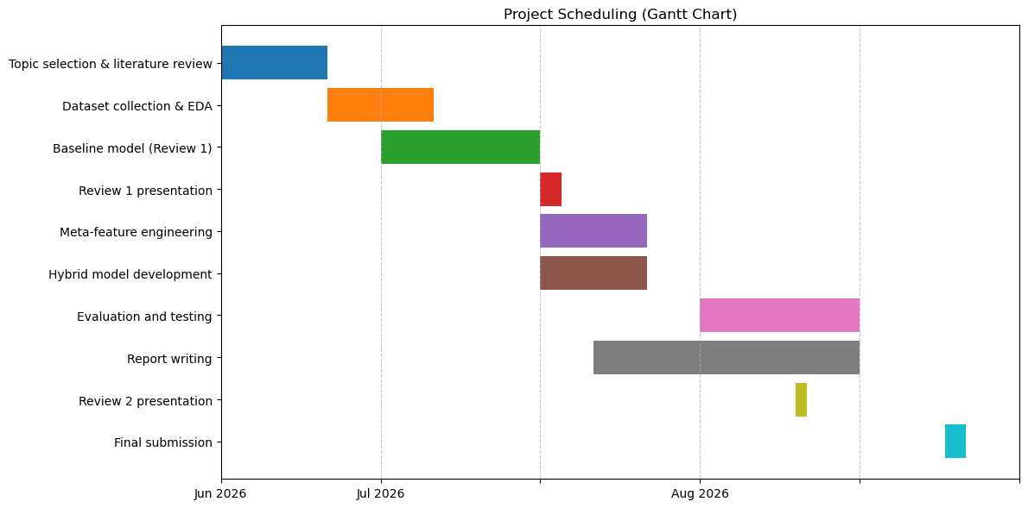
Fig 1.1 Gantt Chart

CHAPTER 2
LITERATURE REVIEW

2. Literature Review
2.1 Overview of Previous Research
Several researchers have proposed different techniques to improve the security of QR codes and detect phishing attacks. Their work includes blockchain-based verification, URL analysis, image processing, deep learning, and hybrid machine learning approaches. A summary of the major studies is presented below.

R. Yalda, A. Khan, and N. Nepal (2026) proposed B-PhishQR, a blockchain-based framework for verifying the authenticity of QR codes. Their system stores QR code information on a blockchain using cryptographic hash functions, helping prevent attacks such as sticker replacement and session hijacking. Although the approach provides strong data integrity, its dependence on blockchain consensus increases processing time. The framework also lacks an efficient mechanism for immediate revocation and depends on secure key management, limiting its suitability for real-time QR code verification.

A. S. Rafsanjani, N. B. Kamaruddin, H. M. Rusli, and M. Dabbagh (2026) developed QsecR, a secure QR code scanning system that focuses on analyzing decoded URLs. The framework extracts lexical, blacklist, host, and content-related features from URLs and evaluates them using datasets such as URLhaus and PhishTank. While the system achieved high detection accuracy, it mainly depends on previously known phishing information and may not perform well against newly created phishing websites. The authors also noted that requesting additional device permissions may raise user privacy concerns.

F. Nejati et al. (2026) introduced CIC-Trap4Phish, a dataset designed for phishing and quishing research. Their framework combines convolutional neural networks with URL analysis to classify malicious content using multiple public datasets. The study established useful benchmark models but reported that existing methods still have difficulty identifying sophisticated visual modifications in QR codes. The authors emphasized the importance of combining image and URL information to improve detection performance.

M. A. Ozuberk and I. Cinar (2026) presented an image-based QR code classification approach using machine learning, deep learning, and explainable techniques. Visual features such as grayscale histograms, Local Binary Patterns (LBP), and Gray-Level Co-occurrence Matrices (GLCM) were extracted to train models including DenseNet121 and LightGBM. Although the approach successfully analyzed QR code images without decoding the embedded URL, it required considerable computational resources and lacked information about the actual destination link.

F. Trad and A. Chehab (2026) investigated machine learning methods that classify QR codes using pixel-level image analysis. Their approach focused on identifying visual distortions and sticker overlays using Decision Trees and XGBoost. While the model was effective for detecting physical modifications, its performance depended on image quality and viewing conditions. Since the decoded URL was not analyzed, the system could not verify the legitimacy of the destination website.

M. W. Akram, K. Sood, M. U. Hassan, and D. Thiruvady (2026) proposed ALFA, a framework designed to detect malicious QR codes with modified visual structures. The method examined finder patterns, alignment markers, timing patterns, and other structural components to identify tampered QR codes. Although effective against structural manipulation, the rule-based approach was less adaptable to newly emerging attack techniques and creatively designed QR codes.

M. W. Akram, K. Sood, and M. U. Hassan (2025) introduced QRïS, which analyzes structural QR code properties such as version information, module count, and error correction level. Machine learning models, including Random Forest and XGBoost, achieved encouraging results using these handcrafted features. However, the study highlighted the need for better feature selection and improved model interpretability to enhance user confidence in prediction results.

F. Ahmed, I. Fatima, M. U. Hassan, I. Rasheed, and U. Fayyaz (2025) presented a comprehensive review of existing malicious QR code detection techniques. Their study compared URL-based and image-based approaches and identified several limitations in current systems. The authors concluded that many solutions analyze only one type of information, either the QR image or the decoded URL, making them less effective against evolving phishing attacks. They recommended developing hybrid detection frameworks that combine multiple feature types while maintaining efficiency and user privacy.
2.2 Review of Machine Learning Techniques
Several machine learning algorithms have been used to detect QR code phishing (Quishing) attacks. Each algorithm has its own advantages depending on the type of features and dataset used.
- Support Vector Machine (SVM): SVM is a supervised learning algorithm that separates legitimate and phishing QR codes by finding the optimal decision boundary. It performs well with high-dimensional data and is widely used for classification tasks.
- Random Forest (RF): Random Forest is an ensemble learning method that combines multiple decision trees to improve prediction accuracy. It is effective in handling complex data patterns while reducing the risk of overfitting.
- Decision Tree (DT): Decision Tree is a simple and interpretable classification algorithm that makes predictions based on a sequence of feature-based decisions. It is easy to understand and provides fast classification.
- XGBoost (XGB): XGBoost is a gradient boosting algorithm that builds decision trees sequentially to improve prediction performance. It is known for its high accuracy and efficiency in solving classification problems.
- LightGBM (LGB): LightGBM is a gradient boosting framework designed for fast training and low memory usage. It performs well on large datasets while maintaining high classification accuracy.
Based on the literature, boosting algorithms such as XGBoost and LightGBM provide an effective balance between accuracy and computational efficiency for hybrid visual and lexical feature-based QR code phishing detection.

2.3 Analysis of Existing Systems
Table 2.1 Literature Review Table
Ref | Author & Year | Detection Technique | QR Code Analysis Method | Features Used | AI/ML Model | Dataset Source | Research Gap
[1] | Yalda et al., 2026 | Blockchain authentication | Cryptographic chaining | Cryptographic hash, metadata, QR ID | Cryptographic | Custom Simulated Blockchain | Traditional systems lack real-time revocation and have shared key vulnerabilities.
[2] | Rafsanjani et al., 2026 | Static feature classification | URL lexical & host analysis | Blacklist, lexical, host, content features | Heuristic rule-based | URLhaus, PhishTank | ML models are data-dependent; excessive app permissions compromise privacy.
[3] | Nejati et al., 2026 | Hybrid (Image & URL) | CNN & Lexical analysis | Spatial patterns, URL tokens | CNN, LLMs, RF, XGBoost | PhishStorm, MalwareBazaar, PhishTank | Lack of comprehensive multi-format datasets covering diverse attachment types.
[4] | Ozuberk & Cinar, 2026 | Image-based | CNN & ML on QR images | Grayscale histogram, LBP, GLCM | DenseNet121, LightGBM, RF | Mendeley Data (1000 images) | Need for URL-independent threat detection combined with explainable AI.
[5] | Trad & Chehab, 2026 | Image-based (QR-centric) | Structural & pixel analysis | Raw QR code pixels | XGBoost, LightGBM, RF, DT | Derived from PhishStorm | URL extraction inherently exposes users to potential malicious payloads.
[6] | Akram et al., 2026 | Structural feature analysis | Binary grid recovery | Finder, alignment, separators, timing | Pre-trained classification model | Custom synthetic dataset | Existing visual/URL methods fail on QR codes.
[7] | Akram et al., 2025 | Structural feature analysis | Protocol-level & statistical | Version, ECC, module count, density | Random Forest, XGBoost | Custom Feat-DataSet-1 & 2 | Deep learning models act as black boxes lacking interpretability and transparency.
[8] | Ahmed et al., 2025 | Systematic review of URL-based, image-based | URL lexical | URL data tokens | Pre-trained classification model | URL Dataset | Disjointed paradigms; lack of scalable, user-friendly real-world security solutions.
[9] | Nigam & Bhandari, 2025 | URL Based Analysis | Lexical analysis | Cryptographic methods | XGBoost | Kaggle | Need for robust systems combining human awareness
[10] | Bhumika K S et al., 2025 | Hybrid (ML + Heuristic) | Decoded text analysis | TF-IDF, URL length, suspicious keywords | XGBoost + Heuristic Engine | Not Reported | Consumer apps decode QR contents without verifying URL properties
[11] | Osari et al., 2025 | Machine Learning URL detection | URL extraction & analysis | URL length, subdomains, HTTPS, suspicious terms | Gradient Boosting, Neural Networks | Labeled dataset of genuine/malicious URLs | Existing mitigation strategies ignore human behavioral elements and user awareness.
[12] | Sarkhi & Mishra, 2024 | ML Classification | Image classification | Visual image patterns | Lightweight DL Model | 651,xxx samples | Low recall specifically for malware classification.
[13] | Vaithilingam & Shankar, 2024 | NLP & Image Processing | Text/Semantic analysis | Textual and semantic features | NLP AI | Small datasets | High computational overhead on mobile devices.
[14] | Sharevski et al., 2024 | Naturalistic user study | Lexical Analysis | URL data tokens | RF,DT | n=42 participants | Small sample size limits behavioral generalizability.
[15] | Ford & Berry, 2024 | Image Recognition | Embedded email image detection | Pixel/image data | CNNs | 200,000 images | High computational demand for high-throughput environments.
[16] | Bhagwani et al., 2024 | API Threat Analysis | Real-time URL scanning | URL reputation/blacklist | API-based | API-based real-time data | Reliance on external APIs causes latency.
[17] | Galadima et al., 2024 | Systematic Review | Decoded Text Analysis | Raw QR code pixels | Pre-trained classiffication Model | Review paper | Lacks empirical testing and novel technical frameworks.
[18] | Ahmer Khalique Khan, 2023 | Heuristic techniques (lexical and host-based) | URL extraction to Phish-Score algorithm | 19 lexical and host-based features | Heuristic algorithm | Curated list of mixed URLs | Existing apps lack user choice and compromise privacy.
[19] | Dhanraj S. et al., 2023 | Machine learning and deep learning | FIND FROM URLS | URL structure, IP addresses, regular expressions | DCNN, RNN, LSTM, ResNet50 | CSV files of URL records | Traditional blacklists fail against zero-day malicious URLs.
[20] | Betty Herlina & Haryono Soeparno, 2023 | Machine learning classification | URL Lexical analysis | 17 features (URL length, IP, domain age, etc.) | XGBoost, RF, DT, SVM, MLP, Autoencoder | Dynamic database via wget | Human failure in QR phishing needs high-accuracy models.

2.4 Limitations of Existing Approaches
Based on the literature review, several limitations in existing QR code phishing detection methods have been identified:
- Limited Adaptability: Many existing systems rely on blacklist databases and predefined rules. These approaches are effective for known phishing websites but struggle to detect newly created or previously unseen phishing domains.
- High Computational Requirements: Deep learning models, especially convolutional neural networks (CNNs), can achieve good detection performance but require significant computational resources. This limits their use on mobile devices and low-resource systems.
- Poor Generalization: Several studies have trained their models on small or limited datasets. As a result, the models often perform well on the training data but show reduced accuracy when tested on new or diverse datasets.
- Limited and Imbalanced Datasets: Many existing approaches are evaluated using relatively small datasets that do not fully represent real-world conditions. Since legitimate QR codes greatly outnumber malicious ones, class imbalance remains a major challenge and can increase false predictions.
These limitations highlight the need for a lightweight and accurate hybrid detection framework that can effectively identify malicious QR codes while maintaining good performance in real-world environments.

CHAPTER 3
DATASET DESCRIPTION
3. Dataset Description
3.1 Overview of the Dataset
The performance of any machine learning model largely depends on the quality and diversity of the dataset used for training and evaluation. In this project, a publicly available QR code phishing dataset was used to develop and test the proposed detection framework. The dataset contains 200,000 QR code samples, with 100,000 legitimate and 100,000 phishing QR codes, providing a balanced distribution between both classes.

The dataset includes QR code images along with their corresponding class labels, allowing the proposed system to learn the characteristics of both safe and malicious QR codes. Using a large and balanced dataset helps the machine learning models capture different QR code structures and phishing patterns while reducing bias during training. It also improves the ability of the models to generalize to unseen QR codes, resulting in more reliable performance in real-world phishing detection scenarios.

3.2 Data Collection Methods
The dataset used in this study was collected from a publicly available source and provided as a compressed ZIP archive containing separate folders for legitimate and phishing QR code images. The images were extracted and organized for further processing before model training.

To efficiently process the large dataset, a Python-based data loading script was developed using ThreadPoolExecutor, allowing multiple images to be processed simultaneously. This reduced the overall data loading time and improved preprocessing efficiency.
During data collection, each PNG image was read using OpenCV and converted into a format suitable for analysis. The loader was designed to ignore corrupted or unreadable image files to ensure data quality. After successfully loading the images, the QR codes were decoded to extract the embedded URLs. Both the visual information from the QR code images and the lexical information from the decoded URLs were then stored as features for use in the machine learning models.

3.3 Data Attributes and Features
After preprocessing, each QR code is represented using a 21-dimensional hybrid feature vector that combines both visual and URL-based information. This combination allows the machine learning models to analyze the QR code from multiple perspectives, improving the accuracy of phishing detection.

The feature vector consists of the following components:
- 14 Visual Features: These features are extracted from the QR code image and include grayscale histogram values, image brightness, pixel intensity statistics, edge density, contour count, and other structural characteristics. They help identify visual abnormalities, image quality, and possible physical modifications in QR codes.
- 7 Lexical URL Features: These features are extracted from the decoded URL and include URL length, domain length, number of dots, digit count, protocol type (HTTP/HTTPS), number of special characters, and the decoding status. These attributes help identify common characteristics found in phishing URLs.

In addition to these features, each sample contains a class label indicating whether the QR code is Legitimate or Phishing. This label serves as the target variable during supervised machine learning training. By combining both visual and lexical features into a single dataset, the proposed framework can effectively detect malicious QR codes that may not be identified using only image analysis or URL analysis alone.
3.4 Dataset Used
The proposed QR code phishing detection system was developed and evaluated using a large-scale public dataset collected from Kaggle. The dataset was selected because it provides a balanced collection of legitimate and phishing QR code images, making it suitable for training and testing machine learning models.

Dataset Details
- Source: Kaggle
- Total Samples: 200,000 QR code images
- Legitimate QR Codes: 100,000
- Phishing QR Codes: 100,000
- Data Format: PNG Images
- Purpose: Used for feature extraction, model training, testing, and performance evaluation

The balanced distribution of legitimate and phishing samples helps minimize class bias during model training. The dataset was used to extract both visual features from QR code images and lexical features from the decoded URLs. These features were then used to train and evaluate the machine learning models, ensuring reliable performance on large-scale QR code phishing detection tasks.

CHAPTER 4
METHODOLOGY
4. Methodology
4.1 System Overview
The proposed system follows a machine learning-based pipeline for detecting QR code phishing (Quishing) attacks. The process begins with a QR code image, which is then processed through multiple stages, including image preprocessing, QR code decoding, feature extraction, feature scaling, machine learning classification, and risk assessment.
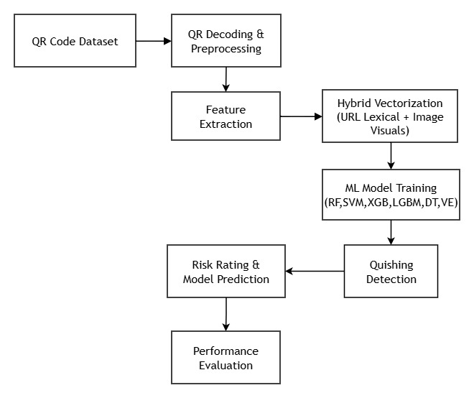
Fig 4.1 Proposed Methodology Diagram
The system first loads the QR code image and converts it into grayscale to simplify image processing. The image is then resized to a standard resolution of 100 × 100 pixels, ensuring that all input images have the same dimensions for feature extraction.

After preprocessing, the QR code is decoded using the OpenCV QRCodeDetector. If a valid URL is found, the system extracts important information from the decoded link. At the same time, several visual characteristics are extracted directly from the QR code image.

The extracted 14 visual features and 7 lexical URL features are combined into a single 21-dimensional hybrid feature vector. Before classification, these features are normalized using standard scaling so that all feature values remain within a comparable range.

The trained machine learning model classifies the QR code as Legitimate or Phishing. Along with the prediction, the system also generates a confidence score and assigns a risk level (Low, Medium, or High) to help users understand the security status of the scanned QR code.

Unlike traditional QR code scanners that simply decode the embedded information, the proposed framework analyzes both the visual structure of the QR code and the characteristics of the decoded URL. This hybrid approach improves detection accuracy and enables the system to identify malicious QR codes more effectively.
4.2 Data Preprocessing
Data preprocessing is an important step in the proposed system. It prepares the input QR code images for feature extraction and improves the overall performance of the machine learning models. The preprocessing stage consists of image loading, resizing, QR code decoding, and URL cleaning.
4.2.1 Grayscale Image Loading and Resizing
The QR code images are first loaded in grayscale using the OpenCV library. Grayscale images contain only intensity values, reducing memory usage and speeding up image processing compared to color images. The loaded image is then resized to 100 × 100 pixels. Since the original dataset contains QR codes of different sizes and resolutions, resizing ensures that every image has the same dimensions before feature extraction.
Benefits of grayscale loading and resizing:
- Reduces memory consumption.
- Improves image processing speed.
- Maintains a consistent image size for all samples.

4.2.2 QR Code Decoding
After preprocessing, the resized image is passed to the OpenCV QRCodeDetector. This module detects the QR code and extracts the information stored inside it. If the QR code contains a valid URL, the decoded text is forwarded to the next stage for further processing. If decoding is unsuccessful, default values are assigned to the URL-related features so that the sample can still be processed without interruption.
Purpose of QR code decoding:
- Detect the QR code within the image.
- Extract the embedded URL.
- Pass the decoded information for feature extraction.

4.2.3 URL Cleaning
The extracted URL may contain unnecessary characters, spaces, or unwanted parameters. Therefore, a URL cleaning process is performed using regular expression (Regex) techniques. The cleaning process helps extract only the important parts of the URL, such as the protocol, domain name, and path.
The URL cleaning process includes:
- Removing unnecessary spaces and unwanted characters.
- Identifying the protocol (HTTP or HTTPS).
- Extracting the domain name.
- Preserving useful URL components for feature extraction.

4.3 Feature Extraction Techniques
Feature extraction is one of the most important stages of the proposed system. In this stage, useful information is extracted from both the QR code image and the decoded URL. Instead of relying only on image analysis or URL analysis, the framework combines both types of information. The extracted features are grouped into visual features and lexical URL features, which together form a 21-dimensional hybrid feature vector.

4.3.1 Visual Feature Extraction
The visual features are extracted directly from the QR code image. These features describe the appearance and structural characteristics of the QR code.
The proposed system extracts the following visual features:
- Grayscale Histogram (8 Features)
  - Measures the distribution of pixel intensity values.
  - Helps identify differences in the visual appearance of QR codes.
  - Histogram values are normalized to ensure consistency across different images.
- Grayscale Mean
  - Represents the average brightness of the QR code image.
  - Useful for identifying changes in image intensity.
- Standard Deviation
  - Measures the variation in pixel intensity values.
  - Indicates the overall contrast of the image.
- Image Entropy
  - Measures the amount of information and complexity present in the QR code.
  - Higher entropy generally indicates more complex image patterns.
- Edge Density
  - Calculated using the Canny Edge Detection algorithm.
  - Measures the number of edge pixels in the QR code.
  - Helps identify structural modifications or unusual visual patterns.
- Contour Count
  - Counts the total number of contours detected in the QR code.
  - Provides information about the structural layout of the image.
- Nested Contours
  - Measures the hierarchical relationship between contours.
  - Helps identify complex QR code structures and possible physical modifications.

4.3.2 Lexical URL Feature Extraction
After successfully decoding the QR code, the embedded URL is analyzed to extract lexical features. These features describe the characteristics of the URL and help identify common phishing patterns.
The following lexical features are extracted:
- URL Length
  - Total number of characters in the URL.
- Domain Length
  - Number of characters in the domain name.
- Dot Count
  - Counts the number of "." symbols in the URL.
  - Multiple subdomains may indicate suspicious links.
- Digit Count
  - Measures the number of numerical digits present in the URL.
- HTTPS Status
  - Indicates whether the URL uses the secure HTTPS protocol.
  - Stored as a binary value (1 for HTTPS and 0 otherwise).
- Special Character Count
  - Counts characters such as -, _, ?, =, &, and %.
  - Excessive use of these characters is often observed in phishing URLs.
- Decoded Flag
  - Indicates whether the QR code was successfully decoded.
  - A value of 1 represents successful decoding, while 0 indicates failure.

4.3.3 Hybrid Feature Vector
The proposed framework combines both visual and lexical information into a single 21-dimensional hybrid feature vector.
Final Hybrid Feature Vector = Visual Features + URL Features
The feature vector consists of:
- 14 Visual Features
- 7 Lexical URL Features
Before being used for model training, all feature values are normalized using Standard Scaling. This ensures that features with larger numerical values do not dominate those with smaller values and helps improve the performance of the machine learning algorithms. By combining image-based and URL-based information, the proposed hybrid feature extraction approach provides a more comprehensive representation of each QR code, leading to better phishing detection accuracy than methods that rely on only one type of feature.

4.4 Machine Learning Algorithms
The proposed QR code phishing detection system was evaluated using six machine learning algorithms. Each algorithm was trained using the extracted hybrid feature vector to determine its effectiveness in distinguishing legitimate QR codes from phishing QR codes. The performance of these models was compared using standard evaluation metrics such as Accuracy, Precision, Recall, F1-Score, and ROC-AUC.
4.4.1 Decision Tree (DT)
Decision Tree is a supervised machine learning algorithm that classifies data by creating a tree-like structure based on feature values. It is simple to understand and provides fast prediction.
Advantages:
- Easy to understand and interpret.
- Fast training and prediction.
- Suitable as a baseline classification model.

4.4.2 Random Forest (RF)
Random Forest is an ensemble learning algorithm that combines multiple decision trees to improve prediction accuracy. The final prediction is obtained through majority voting among all trees.
Advantages:
- Reduces overfitting compared to a single decision tree.
- Handles complex data patterns effectively.
- Produces stable and reliable predictions.
4.4.3 Support Vector Machine (SVM)
Support Vector Machine (SVM) is a supervised learning algorithm that separates data by finding the optimal decision boundary between classes. The proposed system uses LinearSVC for classification.
To obtain prediction probabilities, the model is wrapped using CalibratedClassifierCV.
Advantages:
- Performs well with high-dimensional feature spaces.
- Suitable for binary classification problems.
- Provides reliable classification performance.

4.4.4 XGBoost (XGB)
XGBoost is an advanced gradient boosting algorithm that builds decision trees sequentially to improve prediction accuracy. Each new tree attempts to correct the errors made by the previous trees.
Advantages:
- High classification accuracy.
- Handles complex feature relationships efficiently.
- Reduces prediction errors through boosting.

4.4.5 LightGBM (LGB)
LightGBM is a gradient boosting framework that uses a leaf-wise tree growth strategy. It is designed to provide high accuracy while efficiently handling large datasets.
Advantages:
- High prediction accuracy.
- Efficient memory utilization.
- Suitable for large-scale machine learning tasks.

4.4.6 Voting Ensemble
The Voting Ensemble combines the predictions of multiple machine learning models to improve the overall classification performance. In the proposed system, the ensemble combines the outputs of Random Forest, XGBoost, and LightGBM using a soft voting approach.
The final prediction is obtained by averaging the probability scores generated by the three classifiers.
Advantages:
- Improves overall prediction reliability.
- Reduces the impact of individual model errors.
- Produces balanced classification results by combining multiple algorithms.

4.5 Model Training and Testing
After feature extraction, the generated 21-dimensional hybrid feature vectors were used to train and evaluate the machine learning models. The training process was carried out using a balanced dataset of 200,000 QR code samples, ensuring that the models learned the characteristics of both legitimate and phishing QR codes.
4.5.1 Data Splitting
The complete dataset was divided into training and testing sets before model development.
The dataset was split as follows:
- Training Set: 140,000 samples (70%)
- Testing Set: 60,000 samples (30%)
A stratified sampling technique was used to maintain an equal distribution of legitimate and phishing QR codes in both datasets. This helps prevent bias during model training and provides a fair evaluation of model performance.

4.5.2 Model Training
Before training, all extracted features were normalized using Standard Scaling so that every feature contributed equally during classification.
The proposed system was trained using the following machine learning models:
- Decision Tree (DT)
- Random Forest (RF)
- Support Vector Machine (SVM)
- XGBoost (XGB)
- LightGBM (LGB)
- Voting Ensemble
To improve the quality of the feature set, ANOVA F-Classif feature selection was applied. This technique ranks features according to their importance and helps identify the most informative attributes for classification.

4.5.3 Model Testing
After training, the models were evaluated using the 60,000 unseen testing samples. The testing process measured how effectively each classifier could distinguish between legitimate and phishing QR codes.
The performance of each model was evaluated using the following metrics:
- Accuracy
- Precision
- Recall
- F1-Score
- ROC-AUC
These evaluation metrics provide a comprehensive assessment of the effectiveness and reliability of the proposed QR code phishing detection framework.

4.5.4 Model Deployment and Prediction
After comparing the performance of all classifiers, the best-performing model was selected and saved as a serialized pipeline.
The saved model can be used to classify new QR code images without retraining the entire system. For every new QR code, the same preprocessing and feature extraction steps are performed before the trained model generates the prediction.
The final output of the system includes:
- Prediction: Legitimate or Phishing
- Prediction Confidence
- Risk Rating: Low, Medium, or High
This deployment process enables the proposed framework to analyze new QR codes efficiently while providing users with a clear indication of the potential security risk associated with the scanned QR code.

CHAPTER 5
SYSTEM ARCHITECTURE
5. System Architecture
5.1 System Flowchart Diagram
The system architecture follows a structured and modular machine learning pipeline designed specifically for QR code phishing (quishing) detection. The flowchart represents a step-by-step process that transforms raw QR code images into meaningful security predictions.
The process begins with the Start node, followed by loading the QR Code Dataset, which contains a large collection of QR images labeled as legitimate or phishing. This dataset acts as the foundation for training and evaluating the detection system.
Next, the pipeline moves to the QR Decoding & Preprocessing stage. In this phase, each QR code image is processed by converting it into grayscale, resizing it to a standard dimension, and decoding the embedded URL using OpenCV. Any unnecessary or noisy data in the decoded content is cleaned to ensure consistency for further analysis.
After preprocessing, the data is passed through the Train-Test Split stage. Here, the dataset is divided into training and testing portions, ensuring that the model is evaluated on unseen data while maintaining a balanced distribution of both classes.
The Train ML Models phase follows, where multiple machine learning algorithms are trained using the extracted hybrid features (visual + URL-based). These models learn patterns that distinguish between legitimate and malicious QR codes.
Once training is completed, the system proceeds to the Model Prediction stage. In this phase, the trained model is used to classify new or unseen QR codes based on the learned patterns.
A decision node then evaluates the output with the condition “Is QR Code Phishing?”. Based on the prediction:
- If the output is Yes (1), the system displays a warning message: “Phishing QR Code”, indicating a potential security threat.
- If the output is No (0), the system displays “Safe QR Code”, indicating that the QR code is considered legitimate.
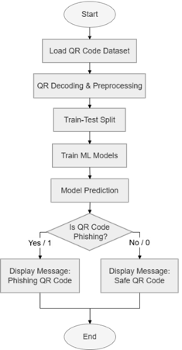
Fig 5.1 Flowchart
5.2 Workflow Explanation
The workflow methodology is structured into four primary, interconnected phases. This modular design guarantees that altering the classification algorithm will not disrupt the preprocessing or feature extraction modules.
The phases include:
- Data Acquisition: QR code images are loaded in grayscale using OpenCV to reduce memory usage and simplify processing.
- Preprocessing: Images are resized to 100 × 100 pixels and decoded to extract the embedded URL.
- Feature Engineering: Visual and URL-based features are combined into a 21-dimensional hybrid vector, followed by scaling.
- Classification and Evaluation: The feature vector is passed to trained models, which classify the QR code and assign a risk level (safe or phishing).

CHAPTER 6
IMPLEMENTATION
6. Implementation
6.1 Tools and Technologies Used
- Programming Language: Python (version 3.10+), chosen for its strong support in data processing and machine learning tasks.
- Environment: Jupyter Notebook and Google Colab were used for development, testing, and experimentation.
- Libraries:
  - OpenCV (cv2): Used for QR code detection, decoding, edge detection, and contour extraction.
  - Pandas and NumPy: Handle dataset operations, numerical computations, and feature matrix creation efficiently.
  - Scikit-learn: Provides tools for preprocessing, feature scaling, feature selection (ANOVA), and models like SVM, Decision Tree, and Random Forest.
  - XGBoost and LightGBM: Used for high-performance classification and better handling of complex patterns.
  - Matplotlib & Seaborn: Help in visualizing results such as confusion matrices and performance graphs.

6.2 Implementation Steps
- Data Loading: The dataset is loaded from a compressed ZIP file. A parallel processing approach using ThreadPoolExecutor is applied to speed up reading and decoding of a large number of images.
- Feature Matrix Generation: Each QR code image is processed through the hybrid feature extraction pipeline. The extracted features are stored in a structured format and saved as quishing_features.csv for reuse and faster experimentation.
- Training Phase: The dataset is split into training and testing sets. Feature scaling is applied, and multiple machine learning models are trained using the processed data.
- Serialization: After training, the best-performing model along with preprocessing steps is saved as quishing_pipeline.pkl. This allows the system to reuse the trained model without repeating the entire training process.
- Scanning / Testing Module: A function such as test_qr_code(img_path) is implemented to perform real-time analysis. It takes a QR image as input, applies preprocessing and feature extraction, and returns the prediction along with a risk indication.

CHAPTER 7
RESULT AND ANALYSIS
7. Results and Analysis
7.1 Performance Metrics
7.1.1 Accuracy
Accuracy shows how many QR codes were classified correctly overall. In this system, XGBoost and LightGBM performed the best, both achieving an accuracy of 97.18%, indicating reliable overall prediction.

7.1.2 Precision
Precision reflects how well the model avoids false alarms. The Random Forest model achieved the highest precision of 98.20%, followed closely by the Voting Ensemble at 98.15%, showing strong performance in correctly identifying safe QR codes.

7.1.3 Recall
Recall measures how effectively the system detects actual phishing QR codes. XGBoost achieved the highest recall of 96.32%, meaning it successfully identified most of the malicious cases with fewer misses.

7.1.4 F1-Score
F1-score provides a balance between precision and recall. XGBoost achieved the highest F1-score of 97.16%, with LightGBM very close at 97.15%, showing consistent and balanced performance across both metrics.

7.2 Comparison of Models
Among all models, XGBoost and LightGBM achieved the highest accuracy (97.18%) and overall balanced performance. XGBoost performed slightly better in recall and F1-score, making it more effective for detecting phishing cases.
The Voting Ensemble also showed strong results with high precision, while Random Forest achieved the highest precision but lower recall. Decision Tree provided stable results, and SVM showed comparatively lower performance.
Overall, XGBoost emerged as the most reliable model due to its balanced and consistent performance across all metrics.
Table 7.1 Model Performance Comparison Table
Model Architecture | Accuracy | Precision | Recall | F1-Score | ROC-AUC
XGBoost | 97.18% | 98.01% | 96.32% | 97.16% | 0.9960
LightGBM | 97.18% | 98.02% | 96.30% | 97.15% | 0.9960
Voting Ensemble | 97.11% | 98.15% | 96.03% | 97.08% | 0.9959
Decision Tree | 96.74% | 97.39% | 96.04% | 96.71% | 0.9852
Random Forest | 96.55% | 98.20% | 94.84% | 96.49% | 0.9947
SVM (Calibrated) | 95.55% | 96.66% | 94.36% | 95.50% | 0.9864

7.3 Outcome
- Confusion Matrix Outcomes:
  - XGBoost: TN = 29,413 | FP = 587 | FN = 1,103 | TP = 28,897
  - LightGBM: TN = 29,415 | FP = 585 | FN = 1,110 | TP = 28,890
  - Random Forest: TN = 29,479 | FP = 521 | FN = 1,548 | TP = 28,452
- ROC Curve Analysis: Both XGBoost and LightGBM achieved the highest ROC-AUC of 0.9960, showing strong ability to separate phishing and legitimate QR codes.
- Testing Verification: The system was tested on sample QR images and correctly identified both cases with high confidence.
Table 7.2 Testing Table
ID | Input Image | Expected | Model Output | Confidence | Risk Rating | Result
1 | benign_test.png | Legitimate | Legitimate | 98.42% | LOW | Pass
2 | malicious_test.png | Phishing | Phishing | 99.95% | HIGH | Pass

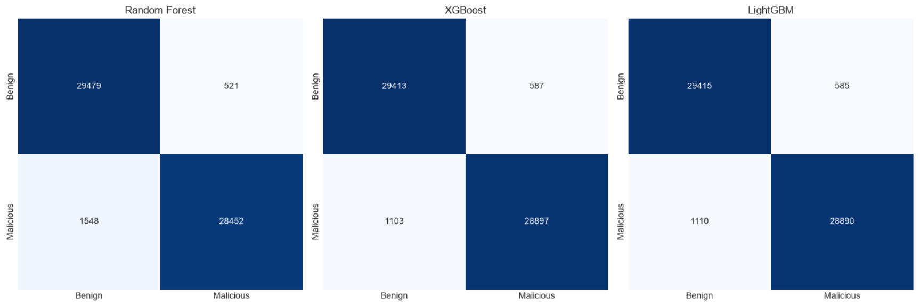
Fig 7.1 Outcome of (RandomForest,XGBoost)
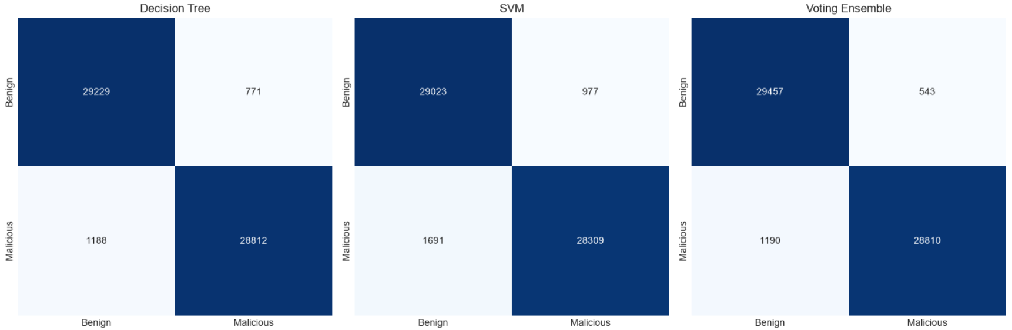
Fig 7.2 Outcome of (LightGBM,DecisionTree)

Fig 7.3 Outcome of (SVM,VotingEnsemble)
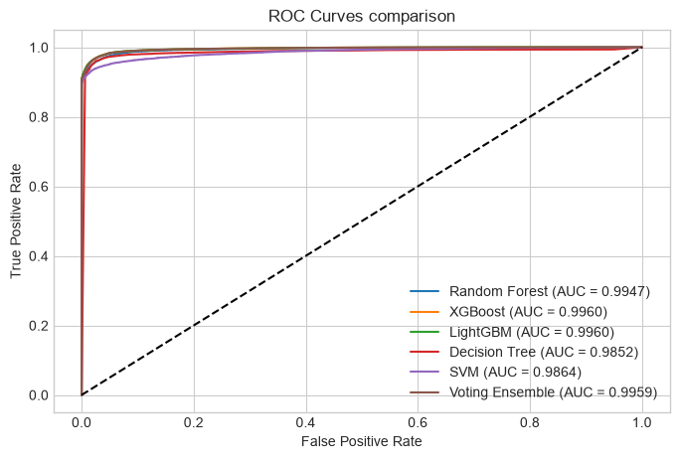
Fig 7.4 ROC Curves Comparison

CHAPTER 8
CONCLUSION
8. Conclusion and Future Enhancements
8.1 Overall Analysis
The proposed hybrid approach provides a reliable solution for detecting quishing attacks by combining visual characteristics of QR codes with features derived from decoded URLs. This two-layer strategy strengthens detection capability, as it does not rely on a single source of information. It performs consistently across different types of QR codes and is suitable for practical use where quick and accurate decisions are required.

8.2 Advantages
- High Accuracy: Achieves an overall accuracy of 97.18%, indicating strong and dependable performance.
- Fast Execution: Models such as LightGBM enable quick predictions, supporting near real-time scanning.
- No External Dependency: The system works locally, reducing delay and maintaining user privacy.
- Balanced Performance: Maintains a good balance between precision and recall, with F1-scores above 97%.
- Scalability: The approach works effectively even on large datasets, making it suitable for real-world deployment.

8.3 Limitations
- Decoding Dependence: The system relies on successful QR decoding; if decoding fails due to damage or distortion, performance may be affected.
- Handling Complex Designs: Highly stylized or artistic QR codes may not be fully captured by the current visual features.

8.4 Future Enhancement
- Deep Learning Integration: Future work can include advanced deep learning models such as lightweight CNNs and transformer-based approaches. These models can learn complex visual patterns and hidden structures in QR codes, improving detection of highly sophisticated or manipulated codes.
- Adversarial Robustness: Further improvements can focus on strengthening the model against evasion techniques. By introducing adversarial training strategies, the system can better handle modified, noisy, or intentionally distorted QR codes used to bypass detection.
- Model Transparency and Explainability: Adding interpretation techniques will help explain why a QR code is marked as safe or risky. This can improve user trust and make the system more understandable in practical applications.
- Mobile and Edge Deployment: Optimizing the model for mobile devices can enable on-device scanning and instant feedback without relying on external servers, making the system faster and more privacy-friendly.

8.5 Project Conclusion and Discussion
The project demonstrates that combining visual and URL-based features leads to better detection performance compared to single-method approaches. The system is capable of identifying phishing QR codes with high accuracy while providing clear and simple risk indications. This makes it useful for everyday scenarios such as payments, public scanning, and authentication processes, helping users make safer decisions and reducing the chances of security breaches.

The results further highlight that the proposed approach achieves strong performance, with models like XGBoost reaching an accuracy of 97.18% along with high precision and recall. This confirms that the system not only detects threats effectively but also maintains a good balance by minimizing both false alarms and missed attacks. Overall, the model proves to be reliable, efficient, and suitable for real-world deployment where both accuracy and speed are essential.

Appendices
APPENDIX A - Project Documents and Data
Project Title: QR Code Phishing Detection System (Quishing Detection)
GitHub Repository: https://github.com/yashtalaviya5/QR-Code-Phishing-Detection-System
Dataset Source: Kaggle
Dataset Size: 200,000 QR Code Images
Dataset Link: https://www.kaggle.com/datasets/samahsadiq/benign-and-malicious-qr-codes
Programming Language: Python
Machine Learning Models: SVM, Decision Tree, Random Forest, XGBoost, LightGBM, Voting Ensemble

APPENDIX B - SDG Mapping
The QR Code Phishing Detection System (Quishing Detection) aligns with two key Sustainable Development Goals:
- SDG 9 (Industry, Innovation, & Infrastructure): Promotes cybersecurity innovation by developing a machine-learning-based QR code phishing detection system. The proposed framework combines QR image features and URL-based features to identify malicious QR codes and strengthen the security of modern digital infrastructure. The system uses a 21-dimensional hybrid feature set and multiple machine learning models for reliable detection.

- SDG 16 (Peace, Justice, & Strong Institutions): Supports safer and more trustworthy digital environments by detecting phishing QR codes before users access potentially malicious websites. The system classifies QR codes as Legitimate or Phishing and provides prediction confidence with Low, Medium, and High risk levels, helping protect users from phishing, credential theft, financial fraud, and unauthorized access.

REFRENCES
[1] R. Yalda, A. Khan, and N. Nepal, "B-PhishQR—A blockchain-based framework for secure QR code verification against phishing attacks," Telematics and Informatics Reports, vol. 21, p. 100289, 2026, doi: 10.1016/j.teler.2025.100289.
[2] A. S. Rafsanjani, N. B. Kamaruddin, H. M. Rusli, and M. Dabbagh, "QsecR: Secure QR code Scanner According to a Novel Malicious URL Detection Framework," IEEE Access, vol. 11, pp. 92523-92539, 2023, doi: 10.1109/ACCESS.2023.3291811.
[3] F. Nejati, M. Rabbani, M. Eskandarian, M. Mirani, G. Piya, I. Opushnyev, A. A. Ghorbani, and S. Dadkhah, "CIC-Trap4Phish: A Unified Multi-Format Dataset for Phishing and Quishing Attachment Detection," arXiv preprint arXiv:2602.09015, 2026.
[4] M. A. Ozuberk and I. Cinar, "Malicious QR Code Classification Using Machine Learning, Deep Learning, and Explainable AI," in 2026 5th IISEC, 2026, pp. 1-6, doi: 10.1109/IISEC69317.2026.11418433.
[5] F. Trad and A. Chehab, "Detecting Quishing Attacks with Machine Learning Techniques Through QR Code Analysis," arXiv preprint arXiv:2505.03451, 2026.
[6] M. W. Akram, K. Sood, M. U. Hassan, and D. Thiruvady, "ALFA: A Safe-by-Design Approach to Mitigate Quishing Attacks Launched via Fancy QR Codes," arXiv preprint arXiv:2601.06768, 2026.
[7] M. W. Akram, K. Sood, and M. U. Hassan, "QRïS: A Preemptive Novel Method for Quishing Detection Through Structural Features of QR," arXiv preprint arXiv:2510.17175, 2025.
[8] F. Ahmed, I. Fatima, M. U. Hassan, I. Rasheed, and U. Fayyaz, "Malicious QR Code Detection: A Comprehensive Review of Methods and Challenges," Spectrum of Engineering Sciences, vol. 3, no. 12, pp. 1462-1472, 2025, doi: 10.5281/zenodo.18196524.
[9] N. Nigam and R. Bhandari, "Performance Analysis of QR Phishing Detection Approaches," Journal of Information Systems Engineering and Management, vol. 10, no. 335, pp. 221-225, 2025.
[10] B. K. S., R. B. Bhuvaneshwari, P. S. Pavan, H. S. Varun, and J. G. C., "AI Based QR Code Fraud Detection System," International Journal of Innovative Research in Science, Engineering and Technology (IJIRSET), vol. 14, no. 12, pp. 22809-22815, 2025, doi: 10.15680/IJIRSET.2025.1412039.
[11] R. Osari, K. K. Baraskar, G. Silakari, P. Jain, P. Jain, and P. Verma, "Design and Analysis of Machine learning based QR Phishing Detection System," IJARSCT, vol. 5, no. 12, pp. 67-76, 2025, doi: 10.48175/IJARSCT-25909.
[12] M. Sarkhi and S. Mishra, "Detection of QR Code-based Cyberattacks using a Lightweight Deep Learning Model," Engineering, Technology & Applied Science Research, vol. 14, pp. 15209–15216, 2024.
[13] S. Vaithilingam and S. A. M. Shankar, "Enhancing Security in QR Code Technology Using AI: Exploration and Mitigation Strategies," International Journal of Intelligence Science, vol. 14, no. 2, pp. 49–57, 2024.
[14] F. Sharevski, M. Mossano, M. F. Veit, G. Schiefer, and M. Volkamer, "Exploring Phishing Threats through QR Codes in Naturalistic Settings," in Proceedings 2024 Symposium on Usable Security, 2024.
[15] J. Ford and H. S. Berry, "Feasibility of Machine Learning-Enhanced Detection for QR Code Images in Email-based Threats," 2024 Cyber Awareness and Research Symposium (CARS), Grand Forks, ND, USA, 2024, pp. 1-9, doi: 10.1109/CARS61786.2024.10778732
[16] M. K. Bhagwani, A. Gangwar, K. Vishwakarma, A. Khare, V. K. Tiwari, and A. Dubey, "Preventing Malware Spread through QR Codes: A Detection and Analysis Approach," J. Eng. Technol. Manage., vol. 73, pp. 1260-1268, Sep. 2024.
[17] S. A. Galadima, M. Shrivastava, and G. Sonowal, "QR Code Phishing: A Review of the Current Attacks and Countermeasures," JuniKhyat, vol. 14, no. 9, no. 3, pp. 1-6, Sep. 2024.
[18] K. A. Khalique, "Detecting Phishing URLs in QR codes using Heuristic Techniques," M.S. thesis, School of Computing, National College of Ireland, Dublin, Ireland, Sep. 2023.
[19] S. Dhanraj, N. B. B. K, N. A. Jain, M. Manisha, and M. Keerthana, "Malicious URL Detection Using Machine Learning and Deep Learning," Int. J. Adv. Res. Comput. Commun. Eng., vol. 12, no. 2, pp. 109-113, Feb. 2023, doi: 10.17148/IJARCCE.2023.12223.
[20] B. Herlina and H. Soeparno, "Machine Learning Model to Improve Classification Performance in the Process of Detecting Phishing URLs in QR Codes," J. Theor. Appl. Inf. Technol., vol. 101, no. 18, pp. 5755-5765, Sep. 2023.

INVENTION DISCLOSURE FORM FOR PATENTS

Applicant Name-Marwadi University

- Particulars of Inventors

Mr./Ms/Dr. | Name (Full) | Department | Designation | Mobile No. | Email | Postal Address
Mr | Yash Talaviya | CE | Student | 9408866115 | yash.talaviya131309@marwadiuniversity.ac.in | Marwadi University
Mr. | Tirth Bhut | CE | Student | 7863078371 | tirth.bhut131162@marwadiuniversity.ac.in | Marwadi University
Mr. | Pratham Gajra | CE | Student | 9924644667 | pratham.gajra131330@marwadiuniversity.ac.in | Marwadi University
Mr | Yogeshwar Prajapati | CE | Asst. Professor | 9898260380 | yogeshwarprajapati2000@gmail.com | Marwadi University

- Provide title of the invention: In 100 words or less, please provide an abstract or summary of the invention:
- An Intelligent Multimodal System for QR Code Phishing Detection and Mitigation
Abstract: This invention presents an intelligent multimodal system for detecting QR code phishing attacks in real time. The system extracts encoded URLs and analyzes QR image characteristics, URL patterns, domain information, redirection behavior, security certificates, and webpage content. A machine learning based fusion engine combines these features to generate a dynamic Quishing Risk Score. Based on the calculated risk, the system classifies each QR code as legitimate, suspicious, or malicious. It provides explainable warnings and automatically permits, blocks, or isolates access before redirection. The proposed approach improves early detection, reduces false alerts, and protects users from credential theft and financial fraud.

- Detail description of the invention:( Answer to all below are required in detail)

  - Problem the invention is solving:
- QR codes hide the destination URL, preventing users from checking it before scanning.
- Attackers manipulate or replace genuine QR codes with malicious QR codes.
- Malicious QR codes redirect users to fake login, banking or payment websites.
- Shortened URLs and multiple redirections make malicious destinations difficult to identify.
- Existing tools mainly analyse URLs after users open them.
- Current systems may not jointly analyse the QR image, URL, domain and webpage.
- Newly created phishing domains may bypass signature-based security systems.
- Users may suffer credential theft, financial fraud, malware infection and data loss.
- The invention analyses threats before allowing access to the destination.
- It warns users and blocks or isolates suspicious and malicious QR-code links.
  - General Utility/application of the invention:
- Banking and Digital Payment Security: The invention may be integrated with banking, UPI and digital-wallet applications to analyse payment QR codes before completing transactions. It can identify manipulated QR codes, suspicious payment links, unauthorised redirections and fake merchant destinations, thereby protecting users from financial fraud.
- Mobile QR Scanner and Camera Applications: The invention can be incorporated into smartphone cameras and QR-scanning applications. Before opening an encoded link, the system analyses the QR image, embedded URL, domain details, security certificate and redirection behaviour. It then allows, warns or blocks access based on the generated risk score.
- Enterprise and Organisational Cybersecurity: Organizations may deploy the invention to examine QR codes present in emails, documents, posters, employee identity cards and internal communication systems. It can prevent employees from accessing fake login portals, credential-stealing websites and malicious downloads through fraudulent QR codes.
- Retail, E-Commerce and Public Services: The invention can protect QR codes used in restaurants, retail stores, advertisements, ticketing systems, product packaging and public-service platforms. It verifies whether the QR code leads to an authorised destination and warns users when physical replacement, visual manipulation or suspicious redirection is detected.
- Email, Browser and Web Security: The invention may be integrated with email gateways, web browsers and browser extensions to detect QR codes embedded in emails and webpages. It can extract and analyse their destinations before users scan or access them, reducing QR-based phishing attacks delivered through digital communication.
- Authentication and Access-Control Systems: The invention can secure QR codes used for login, device pairing, account activation, attendance and identity verification. It detects unauthorised or cloned QR codes and prevents users from submitting credentials or authentication information to fraudulent systems.
- Cybersecurity Monitoring and Incident Response: Security teams may use the invention to monitor phishing campaigns and analyse suspicious QR-code samples. The generated risk score, detection reasons, URL-redirection details and domain indicators can assist investigators in identifying attack patterns, blocking malicious infrastructure and responding to incidents.

  - Advantages of the invention disclose the increased efficiency/efficacy :
- Early Detection Before Redirection: The invention analyses the QR code and its embedded destination before the webpage is opened. This prevents users from reaching phishing websites and reduces the possibility of credential theft, financial fraud and malware infection.
- Multimodal Threat Analysis: The invention jointly examines QR-image characteristics, URL patterns, domain information, SSL/TLS certificates, redirection behaviour and webpage content. Combining multiple data sources improves detection effectiveness compared with systems that analyse only the encoded URL.
- Improved Detection Accuracy: The multimodal fusion engine combines different security indicators to identify both known and previously unseen quishing attacks. This increases detection accuracy and reduces dependence on static blacklists and predefined phishing signatures.
- Reduced False Alerts: The invention generates a dynamic Quishing Risk Score by evaluating the combined importance of multiple indicators. This avoids classifying a QR code as malicious based on only one weak indicator and helps reduce false-positive and false-negative results.
- Detection of Shortened and Redirected URLs: The system expands shortened URLs and traces multiple redirection paths to determine the final destination. This improves its ability to detect attackers who conceal phishing websites behind URL-shortening services or intermediate webpages.
- Detection of QR-Code Manipulation: The image-analysis component can identify visual tampering, overlays, replacement patterns and other suspicious QR-code characteristics. This provides additional protection against physically or digitally manipulated QR codes.
- Real-Time Automated Protection: Based on the calculated risk level, the invention automatically allows, warns, blocks or isolates the QR-code destination. This reduces manual security analysis and enables an immediate response to suspicious QR codes.
- Explainable Detection Results: The invention provides reasons for its classification, such as a newly registered domain, suspicious URL structure, certificate issue, excessive redirections or webpage imitation. This improves user awareness and assists security personnel in verifying detected threats.
- Protection Against Emerging Attacks: By using behavioural, contextual and content-based indicators, the invention can detect newly created phishing websites that may not be available in existing blacklist databases. This improves protection against zero-day and rapidly changing quishing campaigns.
- Scalable and Flexible Deployment: The invention can be deployed as a mobile application, browser extension, security API, cloud service or enterprise security solution. It can analyse multiple QR-code samples automatically, thereby increasing operational efficiency across different environments.

  - Best way of using the invention as well as possible variants :

Best Way of Using the Invention:
- The invention is preferably implemented as a mobile QR-code scanning application.
- The user scans a QR code using the smartphone camera.
- The system decodes the QR code without immediately opening the embedded URL.
- It analyses the QR-code image for possible tampering, replacement, overlays and structural abnormalities.
- The extracted URL is examined for suspicious keywords, shortened links, misleading domains, unusual characters and IP-address-based links.
- The system traces redirection chains to determine the actual final destination.
- Domain age, DNS information, hosting details, reputation and SSL/TLS certificate status are verified.
- The destination webpage is examined in a secure environment for fake login forms, payment requests, malicious scripts and brand impersonation.
- The multimodal fusion engine combines the QR-image, URL, domain, redirection and webpage features.
- A dynamic Quishing Risk Score is generated to classify the QR code as legitimate, suspicious or malicious.
- Based on the risk level, the system automatically allows the link, displays a warning or blocks and isolates the destination.
- The user receives an explainable alert showing the reasons for classifying the QR code as suspicious or malicious.

Possible Variants of the Invention:
- Mobile Application Variant: Integrated into a smartphone camera or dedicated QR-scanning application.
- Browser Extension Variant: Detects and analyses QR codes displayed on websites, emails and online documents.
- Banking Application Variant: Verifies payment QR codes, merchant identities and payment destinations before authorising transactions.
- Digital-Wallet Variant: Protects UPI and wallet users against fraudulent payment requests and replaced merchant QR codes.
- Enterprise Security Variant: Scans QR codes contained in organisational emails, attachments, documents and internal portals.
- Cloud-Based Variant: Provides scalable QR-code analysis through a centralized cloud platform or security API.
- Offline Variant: Performs lightweight QR-image and URL analysis directly on the device without requiring internet access.
- Hybrid Variant: Performs quick analysis locally and sends complex domain and webpage checks to a secure cloud service.
- Email-Gateway Variant: Automatically extracts and analyses QR codes contained in incoming emails and attachments.
- Web-Service/API Variant: Allows third-party applications to submit QR-code images or URLs for security verification.
- Kiosk and Point-of-Sale Variant: Verifies QR codes used at retail counters, ticketing machines and public-service kiosks.
- Authentication Variant: Protects QR codes used for account login, device pairing, identity verification and access control.
  - Working of invention along with Drawing, schematics and flow diagrams if required with complete explanations:
System Architecture:
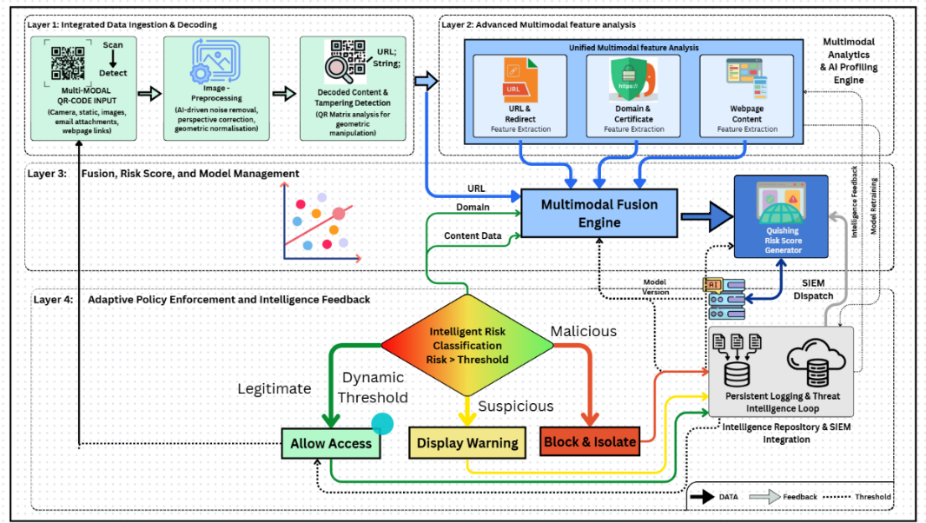

Step-by-Step Working Explanation:
1. Technical Field & Innovation Summary
The disclosed system provides a multi-layered, artificial intelligence-driven mechanism for real-time identification and mitigation of QR code-based phishing (Quishing) threats. By integrating physical image tampering detection with deep multimodal feature evaluation, the system evaluates security risks across isolated data streams (visual, structural, network, and behavioural) and executes automated containment policies before end-user exposure occurs.

2. Multi-Layer Architectural Breakdown
The architecture is structured into four primary functional layers (Layers 1–4), operating sequentially and concurrently to form a closed-loop intelligence architecture:
Layer 1: Integrated Data Ingestion & Physical Preprocessing
- Multimodal QR-Code Input Module: Serves as the primary entry interface, ingesting optical payloads from dynamic sources (live camera sensors) and static digital files (email attachments, uploaded images, rendering DOM elements on web pages).
- Image Preprocessing Module: Normalises raw optical data using computer vision algorithms (e.g., contrast restoration, noise suppression, perspective warping, and geometric alignment) to ensure high decoding fidelity under suboptimal capture conditions.
- Decoded Content & Tampering Detection Module: Extracts the embedded string payload (URL/URI) while simultaneously analysing the physical QR matrix for physical anomalies (e.g., physical sticker overlays, altered finder/alignment patterns, pixel manipulation).
Layer 2: Advanced Multimodal Feature Analysis Engine
- Unified Multimodal Feature Extraction Pipeline:
- URL & Redirect Analysis: Performs static and dynamic path extraction, unrolls shortened links, resolves obfuscated URIs, and traces multi-hop HTTP/HTTPS redirection chains.
- Domain & Certificate Analysis: Inspects domain registration age, WHOIS attributes, SSL/TLS certificate validity, certificate authority trust chains, and cross-checks active threat databases/DNS blocklists.
- Webpage Content Analysis: Renders target destinations in a sandboxed, headless environment to extract visual features (e.g., logo cloning detection via OCR/computer vision) and textual features (e.g., natural language processing for credential-harvesting prompts).
Layer 3: Multimodal Fusion & Risk Score Engine
- Multimodal Fusion Engine: Integrates disparate risk signals (visual, network, structural, and behavioral metrics) into a unified feature vector matrix, resolving conflicting or ambiguous risk signals across individual channels.
- Quishing Risk Score Generator: Passes the unified feature matrix through a trained machine learning classification model to output a continuous, normalized risk score parameter (R є [0, 1]).

Layer 4: Adaptive Policy Enforcement & Threat Intelligence Feedback
- Intelligent Risk Classification Router: Compares the generated risk score against dynamic security thresholds to determine enforcement routing:
- Allow Access (Legitimate): Routed when $R< Threshold _{\text{low}}$ granting the user seamless navigation to the destination.
- Display Interstitial Warning (Suspicious): Routed when ${\text{Threshold}}_{\text{low}}≤R<{\text{Threshold}}_{\text{high}}$presenting an inline warning detailing flagged risk indicators.
- Block and Isolate (Malicious): Routed when $R≥{\text{Threshold}}_{\text{high}}$, actively dropping the session, isolating the network path, and neutralising execution.
- Persistent Logging & Threat Intelligence Loop: Archives all operational metadata, session indicators of compromise (IOCs), and classification outcomes. This module actively feeds telemetry back into the system to retrain AI/ML models and dispatches real-time updates to enterprise SIEM/SOAR platforms.

- Have you conducted Primary Patent Search? Yes / No (if yes, attach the patent search results)
- We already checked in IPR Portal, USPTO and Google Patent

- List out the known ways about how others have tried to solve the same or similar problems? Indicate the disadvantages of these approaches. In addition, please identify any prior art documentation or other material that explains or provides examples of such prior art efforts

S. No. | Existing State of the Art | Drawbacks in Existing State of the Art | How the Present Invention Overcomes the Drawback
1 | Threshold-based matrix-barcode phishing detection: The system analyses encoded addresses and generates a phishing notification when a calculated value exceeds a threshold. It may warn the user or block website access. Prior art: US9344450B2 – Detecting Phishing of a Matrix Barcode. | The approach is primarily based on encoded address information and threshold-based evaluation. It does not describe comprehensive fusion of QR-image tampering, URL, redirect, domain, certificate and webpage-content features. | The present invention performs multimodal analysis and combines QR image, URL, domain, redirect, and webpage features to generate a dynamic Quishing Risk Score.
2 | Secure data transfer using legitimate QR codes: A legitimate QR code is used for transferring data, and a warning is generated when the transfer is identified as malicious. Prior art: US8296477B1 – Secure Data Transfer Using Legitimate QR Codes. | The approach concentrates on securing data transfer through generated legitimate QR codes. It may not adequately detect externally created, physically replaced or digitally manipulated QR codes encountered in public environments. | The present invention accepts QR codes from physical and digital sources and examines them for overlays, replacement marks, structural irregularities and malicious destinations.
3 | Cryptographically secured QR-code service: Static or dynamic secure QR codes are generated and verified through a controlled security service to prevent phishing and QR-code manipulation. Prior art: WO2019099089A1 – Secure QR Code Service. | The method generally depends on QR codes being generated and managed within the secured service. Ordinary third-party or legacy QR codes may not contain the required security information. | The present invention analyses both secured and ordinary QR codes without requiring the original issuer to generate a special QR-code format or cryptographic token.
4 | Secure QR-code management and replacement protection: A managed QR-code platform controls QR-code destinations and addresses the problem of malicious replacement or redirection. Prior art: US12200151B2 – Systems and Methods for Providing Security for QR Codes. | The approach is mainly suitable for QR codes managed within a dedicated platform. Its protection may depend on prior registration, controlled generation or management of the QR code. | The present invention provides scan-time analysis of unknown QR codes using image, URL, domain, redirect and webpage indicators, even when the QR code is not previously registered.
5 | Inbound barcode detection and URL rewriting: QR codes contained in organizational emails or attachments are detected, removed or rewritten so that their URLs can be checked by a scanning service. Prior art: US12542814B2 – Detection of Barcode URL in an Organization Inbound Message. | This approach is primarily intended for inbound organizational communications. It may not protect QR codes scanned from posters, parking meters, restaurant menus, payment counters or other physical locations. | The present invention can operate through mobile cameras, scanner applications, browsers, email gateways and enterprise systems, covering both physical and digital QR-code sources.
6 | Protected QR scanner using operating-system control: A protected scanner restricts or overrides the normal QR-scanning operation to prevent malicious links from compromising the device. Prior art: US12008105B2 – Protected QR Code Scanner Using Operational System Override. | The protection is centred on controlling the scanning and destination-opening operation. It does not necessarily provide detailed multimodal threat classification or explainable detection results. | The present invention analyses multiple threat indicators, assigns a risk category and explains the reasons for warning or blocking the destination.
7 | Direct QR-image and pixel-pattern classification: Machine-learning models analyse the structure and pixel patterns of a QR code without extracting its encoded URL. Prior art: Detecting Quishing Attacks with Machine Learning Techniques Through QR Code Analysis. | Image-only analysis may detect structural patterns but cannot completely evaluate the final URL, domain reputation, redirect chain, certificate condition or phishing webpage content. | The present invention combines QR-image analysis with encoded-content and destination analysis, enabling both visual and destination-based threat detection.
8 | Lightweight deep-learning classification: A deep-learning model classifies QR-code samples as normal, phishing or malware using QR-image features. Prior art: Detection of QR Code-Based Cyberattacks Using a Lightweight Deep Learning Model. | The reported system has lower recall for the malware category and primarily concentrates on image-based classification. It does not fully analyse live domains, URL redirects and webpage behaviour. | The present invention combines image classification with live URL, domain, certificate, redirection and webpage analysis to provide broader protection and reduce missed threats.
9 | QR-image feature extraction using CNN–RNN architecture: Image features are extracted using a convolutional model, reduced through PCA and classified using a recurrent neural network. Prior art: Efficient Malicious QR Code Detection Using an Ensemble Deep Learning Approach. | The approach mainly depends on learned QR-image patterns and training-data coverage. New attacks having visually ordinary QR codes but malicious destination behaviour may remain difficult to identify. | The present invention examines the actual encoded destination and contextual behaviour in addition to the QR image, improving detection of visually normal but malicious QR codes.
10 | Heuristic and machine-learning URL detection: Encoded URLs are extracted from QR codes and classified using lexical URL, website-structure and JavaScript-related features. Prior art: Detecting Phishing URLs in QR Codes Using Heuristic and Machine Learning Techniques. | URL-centred detection may fail to detect QR image replacement or tampering. It can also be affected by shortened URLs, multiple redirects, newly registered domains and changes in phishing URL patterns. | The present invention traces redirects, checks the final domain and webpage, analyses QR-image tampering and combines all results through a multimodal fusion engine.

- List the Technical features and Elements of the invention along with the Description of your invention from start to end.:
A. Technical Features and Elements:

S. No. | Technical Feature/Element | Description
1 | Multisource QR-Code Acquisition | Accepts QR codes from smartphone cameras, static images, email attachments, webpages and digital documents.
2 | Controlled QR Decoding | Decodes the QR content without automatically opening the embedded URL, thereby preventing immediate exposure to a malicious destination.
3 | AI-Based Image Preprocessing | Applies noise removal, perspective correction, rotation correction, resizing, contrast enhancement and geometric normalisation to improve decoding and analysis.
4 | QR Tampering Analysis | Examines QR-matrix structure and image characteristics to identify overlays, replacement, distortion and possible geometric manipulation.
5 | URL and Redirect Analysis | Extracts lexical and structural URL features, expands shortened URLs and traces intermediate redirects to identify the final destination.
6 | Domain and Certificate Verification | Checks domain age, DNS information, registration details, domain reputation and SSL/TLS certificate validity.
7 | Secure Webpage-Content Analysis | Analyses the destination webpage in an isolated environment for fake login forms, payment requests, brand impersonation, hidden content and malicious scripts.
8 | Multimodal Feature Fusion | Combines QR-image, decoded-content, URL, redirect, domain, certificate and webpage features into a unified security profile.
9 | Quishing Risk Score | Generates a combined numerical score indicating the probability and severity of a QR-code phishing attack.
10 | Dynamic Risk Threshold | Adjusts the classification threshold according to the input source, QR-code type, contextual risk, model confidence and threat intelligence.
11 | Intelligent Risk Classification | Classifies each QR code as legitimate, suspicious or malicious based on the risk score and dynamic threshold.
12 | Adaptive Policy Enforcement | Automatically allows legitimate destinations, displays warnings for suspicious destinations and blocks or isolates malicious destinations.
13 | Explainable Detection | Identifies the main reasons for classification, such as suspicious domain, invalid certificate, fake login form or excessive redirection.
14 | Persistent Security Logging | Records the QR-code source, destination, extracted features, risk score, classification and action performed.
15 | Threat-Intelligence Feedback | Uses confirmed malicious indicators and earlier detection results to improve future analysis and model performance.
16 | Model Management and SIEM Integration | Supports model versioning, security-model updates and dispatching alerts to an organizational SIEM platform.

B. Description of the Invention from Start to End
- QR-Code Collection: The operation begins when a user scans a QR code or submits a QR-code image obtained from an email, document, webpage or other digital source.
- Secure Interception: The invention intercepts the QR-code content and prevents the embedded destination from opening automatically. The content remains restricted until the security assessment is completed.
- Image Enhancement: The QR image is processed to remove noise and correct blur, rotation, perspective, lighting and geometric distortion.
- Decoding and Tampering Detection: The enhanced QR code is decoded to extract its embedded content. Simultaneously, its image and matrix structure are examined for overlays, replacement, unusual distortion and other manipulation indicators.
- Content-Type Identification: The decoded content is identified as a URL, text string, payment request, authentication link, application-download link or other data type.
- URL Feature Analysis: If a URL is detected, the invention examines its length, special characters, subdomains, suspicious keywords, IP-address usage, encoded characters, brand similarity and URL-shortening services.
- Redirection Analysis: Shortened links are expanded, and intermediate redirects are followed within a controlled environment. The complete redirection chain and final destination are identified.
- Domain Verification: The final destination is examined using domain age, registration details, DNS information, hosting data, reputation records and similarity with legitimate domains.
- Certificate Verification: The SSL/TLS certificate is checked for validity, issuer, expiry date and correspondence with the destination domain.
- Webpage Analysis: The destination webpage is examined in an isolated environment. The invention detects login forms, password fields, payment requests, brand imitation, hidden elements, suspicious scripts and unauthorized downloads.
- Feature Fusion: The features obtained from the QR image, decoded content, URL, redirect chain, domain, certificate and webpage are combined by the Multimodal Fusion Engine.
- Risk-Score Generation: The fused feature set is analysed using a machine-learning, deep-learning, ensemble or hybrid model to calculate the Quishing Risk Score.
- Dynamic Threshold Selection: The system determines an appropriate threshold based on contextual conditions. Higher security sensitivity may be applied to QR codes associated with banking, payments, authentication and unknown sources.
- Risk Classification: The generated score is compared with the selected threshold:
  - A low-risk QR code is classified as legitimate.
  - A medium-risk QR code is classified as suspicious.
  - A high-risk QR code is classified as malicious.
- Security Action: The invention permits access to a legitimate destination, displays an explainable warning for a suspicious destination, and blocks or isolates a malicious destination.
- Result Logging: The invention records the source, final URL, redirect chain, detected indicators, risk score, classification result and security action.
- Threat-Intelligence Feedback: Confirmed malicious domains, URLs, redirect patterns and webpage indicators are added to the threat-intelligence repository.
- Model and SIEM Update: The stored intelligence supports model improvement, threshold adjustment and model version management. In an enterprise deployment, malicious-event information is transmitted to the SIEM system for monitoring and incident response.
- List out the features of your invention which are believed to be new and distinguish them over the closest technology.

The following claims define the features of the present invention that are believed to be novel and distinguish it from the closest existing technologies.
Claims:
- A QR-code phishing detection and prevention system, comprising QR-code acquisition, image preprocessing, tampering detection, multimodal feature analysis, feature fusion, risk-score generation, intelligent classification and adaptive policy enforcement, wherein the QR code and its encoded destination are analysed before access to the destination is permitted.
- The system as claimed in Claim 1, wherein QR-image characteristics, encoded URL features, redirection behaviour, domain information, SSL/TLS certificate details and destination webpage content are jointly analysed to detect a QR-code phishing attack.
- The system as claimed in Claim 1, wherein QR-code overlays, physical replacement, structural irregularities, geometric distortion or digital manipulation are detected together with malicious destination behaviour.
- The system as claimed in Claim 1, wherein shortened URLs and intermediate redirections are traced in an isolated environment to identify the final destination without exposing the user’s active browser session.
- The system as claimed in Claim 1, wherein the Multimodal Fusion Engine combines QR-image, URL, redirection, domain, certificate and webpage-content features to generate a dynamic Quishing Risk Score.
- The system as claimed in Claim 1, wherein a risk-classification threshold is dynamically adjusted according to the QR-code source, encoded-content type, application context, model confidence and available threat intelligence.
- The system as claimed in Claim 1, wherein the QR code is classified as legitimate, suspicious or malicious and the system respectively permits access, displays an explainable warning, or blocks and isolates the destination.
- The system as claimed in Claim 1, further comprising a persistent threat-intelligence feedback mechanism configured to record detection results and support model updates, threshold adjustment and SIEM-based security monitoring.

Principal Novelty of the Invention

The principal novelty of the present invention lies in the unified and coordinated integration of pre-redirection QR-code interception, QR-image tampering detection, multimodal analysis of URL, redirection, domain, SSL/TLS certificate and webpage-content features, dynamic Quishing Risk Score generation, context-adaptive classification and automated security enforcement.

Unlike conventional approaches that generally analyse either the QR-code image or its encoded URL independently, the present invention jointly examines the QR code and its final destination before user access is permitted. The persistent threat-intelligence feedback mechanism further supports continuous improvement of the detection model, classification thresholds and organisational security monitoring.

- Has the invention been built or tested or implemented? If yes please provide the Efficiency/Efficacy details of the invention –(In Progress)

9. Briefly state when and how you first conceived this idea?

10. Have you sold, offered for sale, publicly used or published anything related to this invention? If yes, please briefly explain the dates and circumstances. List those individuals to whom you have revealed your invention. Were non-discloser documents signed before discloser in each case? Please state any deadlines of which you may be aware for filing an application on this invention.

- Include any reasons that your invention would not have been obvious to someone of average skill in the art.

- Additional comments by inventor (if you want to give more details out of scope of this IDF).
The proposed invention provides preventive protection against QR-code phishing by analysing the QR code and its destination before permitting access. It may be implemented as a mobile application, browser extension, banking-security module, cloud API or enterprise security solution. The invention is not limited to a particular machine-learning algorithm and may support on-device, cloud or hybrid processing. Its threat-intelligence feedback mechanism enables continuous improvement using newly detected malicious URLs, domains and QR-code patterns. The proposed architecture is a preferred implementation, and suitable modifications may be made without changing the essential scope of the invention.

- Drawings/Flowchart/Table

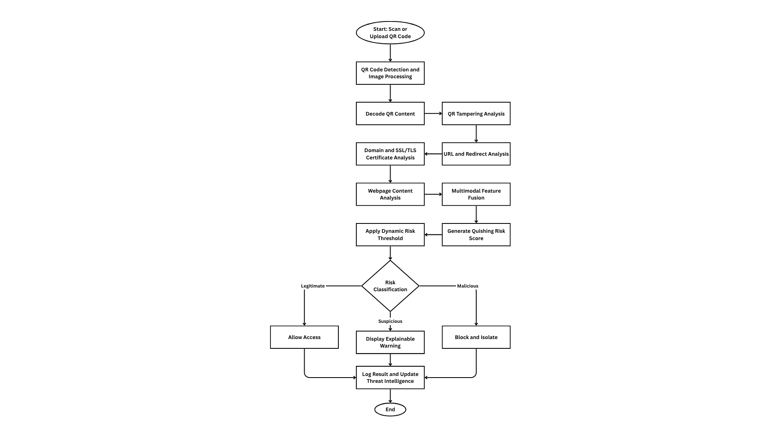

Consent for Filing Patent/Research Publication Application

We, Prof. Yogeshwar Prajapati, Yash Talaviya, Tirth Bhut, Pratham Gajra hereby give our full consent and authorization for the filing of a patent/research publication application for the project titled " QR Code Phishing Detection System (Quishing Detection)".
We hereby authorize Marwadi University and/or its legal representatives to file the patent/research publication application and act on our behalf regarding any matters related to this filing.

Date:
Name: Prof. Yogeshwar Prajapati
Signature:

Date:
Name: Yash Talaviya
Signature:

Date:
Name: Tirth Bhut
Signature:

Date:
Name: Pratham Gajra
Signature:

A Hybrid Machine Learning Framework for QR Code Phishing (Quishing) Detection
Yash Talaviya, Tirth Bhut, Pratham Gajra, and Prof. Yogeshwar Prajapati
Department of Computer Engineering, Marwadi University, Rajkot, Gujarat, India
Abstract— Quick Response (QR) codes are widely used for digital payments, authentication, ticketing, marketing, and information sharing because they provide a fast and convenient way to access online resources. However, their growing popularity has also led to an increase in QR code phishing (Quishing) attacks, where attackers embed malicious URLs inside QR codes to redirect users to fake websites designed to steal personal or financial information. Since users cannot identify the embedded content by simply looking at a QR code, they often scan it without verification, making such attacks difficult to detect. This paper presents a hybrid machine learning framework for detecting malicious QR codes by combining image-based and URL-based analysis. The proposed approach extracts a 21-dimensional feature vector consisting of 14 visual features from QR code images and 7 lexical features from the decoded URLs. A balanced dataset of 200,000 QR codes, including 100,000 legitimate and 100,000 malicious samples, is used for training and evaluation. Six machine learning models Support Vector Machine (SVM), Decision Tree (DT), Random Forest (RF), XGBoost, LightGBM, and a Voting Ensemble are compared to identify the most effective classifier. Experimental results show that XGBoost and LightGBM achieve the best performance, with an accuracy of 97.18% and an F1-score of 97.16%. The framework also includes a three-level risk assessment (Low, Medium, and High) to warn users before opening suspicious links, making it suitable for real-time QR phishing detection.

I. Introduction
Quick Response (QR) codes have become an important part of everyday digital interactions by providing a simple and efficient way to connect physical objects with online services. Today, they are commonly used for mobile payments, contactless restaurant menus, event ticketing, product promotions, and multi-factor authentication (MFA). Their convenience, low cost, and ease of use have made them popular across both personal and business applications. However, the increasing dependence on QR codes has also created new cybersecurity challenges, particularly the rise of QR code phishing attacks, widely known as Quishing.
Unlike traditional phishing, where attackers send malicious links directly through emails or messages, Quishing hides these links inside QR code images. Because the actual URL is encoded within the image, users cannot determine the destination before scanning it with a mobile device. In many cases, conventional email security systems focus on detecting suspicious text, harmful links, or known malicious domains, while QR code images receive little or no inspection. As a result, phishing emails containing QR codes can bypass existing security filters and reach users without raising immediate suspicion. Once scanned, the QR code may redirect victims to fraudulent websites that imitate trusted services and attempt to steal sensitive information such as login credentials, banking details. This growing threat highlights the need for intelligent detection techniques capable of identifying malicious QR codes before users interact with them.

II. Related Work
As the adoption of QR codes continues to increase across digital payments, authentication, ticketing, and marketing, researchers have developed various techniques to detect QR code phishing (Quishing) attacks. Early detection methods primarily relied on blacklist services and rule-based security systems that compared scanned URLs against databases of known malicious websites. While these approaches are effective for detecting previously identified threats, they perform poorly against newly registered phishing domains, shortened URLs, and rapidly changing attack patterns. Since cybercriminals can continuously create new domains and modify their phishing strategies, blacklist-based detection alone is no longer adequate.
To overcome these limitations, many researchers introduced machine learning techniques that analyze the URL extracted from a scanned QR code. Features such as URL length, domain length, number of subdomains, numerical digits, and protocol type are commonly used with classifiers including Support Vector Machine (SVM), Random Forest (RF), and Naïve Bayes. However, these methods depend entirely on successful QR code decoding, making them ineffective when QR codes are damaged, blurred, or intentionally altered.
Another line of research focuses on image-based analysis, where visual patterns, texture features, and deep learning models are used to identify suspicious QR codes. Although these approaches eliminate the dependency on URL decoding, they require higher computational resources and often fail to differentiate similar QR codes containing different URLs.
Recent hybrid approaches combine visual QR features with URL characteristics to improve detection performance. However, most existing systems rely on static analysis, use limited datasets, or analyze only one type of feature. This work addresses these limitations by proposing a lightweight hybrid framework with a 21-dimensional feature set and multi-level risk assessment for accurate real-time Quishing detection.

TABLE I Literature Review

Ref | Author & Year | Detection Technique | QR Code Analysis Method | Features Used | AI/ML Model | Dataset Source | Research Gap
[1] | Yalda et al., 2026 | Blockchain authentication | Cryptographic chaining | Cryptographic hash, metadata, QR ID | Cryptographic | Custom Simulated Blockchain | Traditional systems lack real-time revocation and have shared vulnerabilities.
[2] | Rafsanjani et al., 2026 | Static feature classification | URL lexical & host analysis | Blacklist, lexical, host, content features | Heuristic rule-based | URLhaus, PhishTank | ML models are data-dependent; excessive app permissions compromise privacy.
[3] | Nejati et al., 2026 | Hybrid (Image & URL) | CNN & Lexical analysis | Spatial patterns, URL tokens | CNN, LLMs, RF, XGBoost | PhishStorm, MalwareBazaar, PhishTank | Lack of comprehensive multi-format datasets covering diverse attachment types.
[4] | Ozuberk & Cinar, 2026 | Image-based | CNN & ML on QR images | Grayscale histogram, LBP, GLCM | DenseNet121, LightGBM, RF | Mendeley Data (1000 images) | Need for URL-independent threat detection combined with explainable AI.
[5] | Trad & Chehab, 2026 | Image-based (QR-centric) | Structural & pixel analysis | Raw QR code pixels | XGBoost, LightGBM, RF, DT | Derived from PhishStorm | URL extraction inherently exposes users to malicious payloads.
[6] | Akram et al., 2026 | Structural feature analysis | Binary grid recovery | Finder, alignment, separators, timing | Pre-trained classification model | Custom synthetic dataset | Existing visual/URL methods fail on QR codes.
[7] | Akram et al., 2025 | Structural feature analysis | Protocol-level & statistical | Version, ECC, module count, density | Random Forest, XGBoost | Custom Feat-DataSet-1 & 2 | Deep learning models act as black boxes lacking interpretability,transparency.
[8] | Ahmed et al., 2025 | Systematic review of URL-based, image-based | URL lexical | URL data tokens | Pre-trained classification model | URL Dataset | Disjointed paradigms; lack of scalable, user-friendly security solutions.
[9] | Nigam & Bhandari, 2025 | URL Based Analysis | Lexical analysis | Cryptographic methods | XGBoost | Kaggle | Need for robust systems combining human awareness with technical.
[10] | Bhumika K S et al., 2025 | Hybrid (ML + Heuristic) | Decoded text analysis | TF-IDF, URL length, suspicious keywords | XGBoost + Heuristic Engine | Not Reported | Consumer apps decode QR contents without verifying URL properties or parameters.

III. Proposed Methodology
The proposed QR Code Phishing Detection System follows a sequential processing pipeline that converts a QR code image into a phishing risk prediction. The framework consists of five major stages: dataset preparation, preprocessing and QR decoding, hybrid feature extraction, model training, and risk assessment. Figure 1 illustrates the overall workflow of the proposed system.

Fig. 1 Proposed Methodology

A. Dataset Preparation
The experiments are carried out using a balanced QR code dataset collected from Kaggle. The dataset contains 200,000 PNG images, equally divided into 100,000 legitimate and 100,000 phishing QR codes. Legitimate samples represent trusted websites, while phishing samples contain malicious URLs designed for fraudulent activities. Maintaining an equal number of samples in both classes helps reduce bias during model training and removes the need for oversampling methods.

B. Image Preprocessing and QR Decoding
Before feature extraction, every QR code image passes through a preprocessing stage to ensure consistent input quality and improve computational efficiency.
The image is first loaded in grayscale using the OpenCV cv2.IMREAD_GRAYSCALE function, which reduces memory usage and simplifies image processing. Each image is then resized to 100 × 100 pixels, and pixel values are normalized according to
$$I_{\text{norm}}=\frac{I\left(x,y\right)}{255.0}$$
where $I\left(x,y\right)$ represents the grayscale intensity at pixel location $\left(x,y\right)$.
After preprocessing, the OpenCV QRCodeDetector is used to decode the embedded QR content. The decoded text is cleaned using a regular-expression filter,
$\text{Clean URL}=\text{regex_filter}\left(\text{Decoded Text}\right)$
which removes unwanted characters and extracts the valid URL. If the QR code cannot be decoded successfully, default values are assigned to the corresponding lexical features to maintain a consistent feature vector.

C. Hybrid Feature Extraction
The proposed framework generates a 21-dimensional feature vector by combining information obtained from the QR image and the decoded URL.
The 14 visual features describe the structural properties of the QR code, including an 8-bin grayscale histogram, average pixel intensity, standard deviation, image entropy, edge density, contour count, and nested contour information. These features capture the overall appearance, texture, and structural complexity of the QR code.
The remaining 7 lexical features are extracted from the decoded URL. These include URL length, domain length, number of dots, digit count, protocol type (HTTP/HTTPS), count of special characters, and a decoding status flag. Together, these features represent the characteristics commonly observed in phishing URLs.

D. Feature Selection and Data Caching
Feature extraction from thousands of QR code images is computationally intensive. To reduce repeated processing time, all extracted features are stored in a CSV file after the first execution. During subsequent experiments, the system loads these cached features directly, significantly reducing preprocessing time.
To identify the most informative attributes, ANOVA F-Classif is used for feature selection. In addition, a correlation analysis is performed to reduce features and improve the overall learning performance of the classification models.

E. Classification Models
Six machine learning models are evaluated in this study: Decision Tree (DT), Random Forest (RF), Support Vector Machine (SVM), XGBoost, LightGBM, and a Voting Ensemble. The ensemble model combines the probability scores produced by Random Forest, XGBoost, and LightGBM using a soft-voting strategy, allowing the final prediction to benefit from the strengths of multiple classifiers.
$P\left(y=c\right)=\frac{1}{3}\left[P_{RF}\left(y=c\right)+P_{XGB}\left(y=c\right)+P_{LGB}\left(y=c\right)\right]$
The ensemble improves overall robustness by combining the strengths of multiple classifiers.

F. Risk Assessment
To make the prediction easier for users to understand, the system categorizes each scanned QR code into one of three risk levels: Low, Medium, or High. The risk level is determined using the predicted class along with the model's confidence score. High-confidence phishing predictions are labeled as High Risk, confident legitimate predictions are marked as Low Risk, and uncertain predictions are classified as Medium Risk, providing users with a clear indication of potential security threats before opening the scanned link.

IV. Experimental Setup
The proposed QR code phishing detection system was implemented in Python using OpenCV (4.10+) for image processing, Scikit-learn (1.5+) for machine learning, and the XGBoost and LightGBM libraries for boosting models.
Experiments were performed on a system with an Intel Core i5/i7 processor, 8 GB RAM, and a Windows/Linux operating system. To improve processing speed, QR code images were processed in parallel using ThreadPoolExecutor with 16 worker threads.
The extracted dataset of 200,000 QR codes was divided into 70% training (140,000 samples) and 30% testing (60,000 samples) using stratified sampling to maintain class balance.

Performance Metrics: The proposed models were evaluated using standard classification metrics, including Accuracy, Precision, Recall, F1-Score, ROC-AUC, and Training Time.
$\text{Precision}=\frac{TP}{TP+FP}$
$\text{Recall}=\frac{TP}{TP+FN}$
$\text{F1-Score}=2×\frac{\text{Precision}×\text{Recall}}{\text{Precision}+\text{Recall}}$
These metrics provide a comprehensive evaluation of both detection performance and computational efficiency.

V. Result and Discussion
A. Performance of Individual Models
The confusion matrix was used to evaluate the classification performance of all six machine learning models. It provides a detailed view of correctly and incorrectly classified QR codes by reporting the number of True Negatives (TN), False Positives (FP), False Negatives (FN), and True Positives (TP). In phishing detection, reducing False Negatives is essential because undetected malicious QR codes may expose users to phishing attacks, while minimizing False Positives helps prevent legitimate QR codes from being incorrectly flagged.
The results were obtained using the 60,000-sample test set, which consists of 30,000 legitimate and 30,000 phishing QR codes.

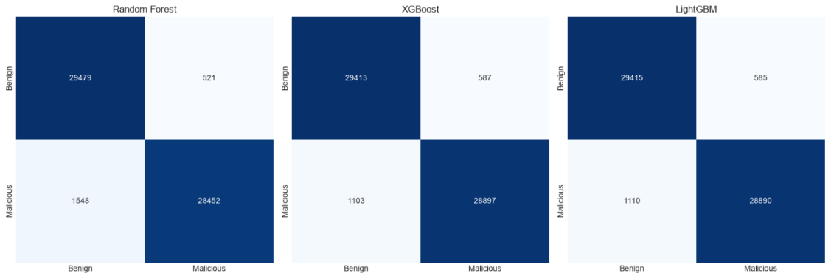
Fig. 2 Confusion matrices for RF and XGBoost

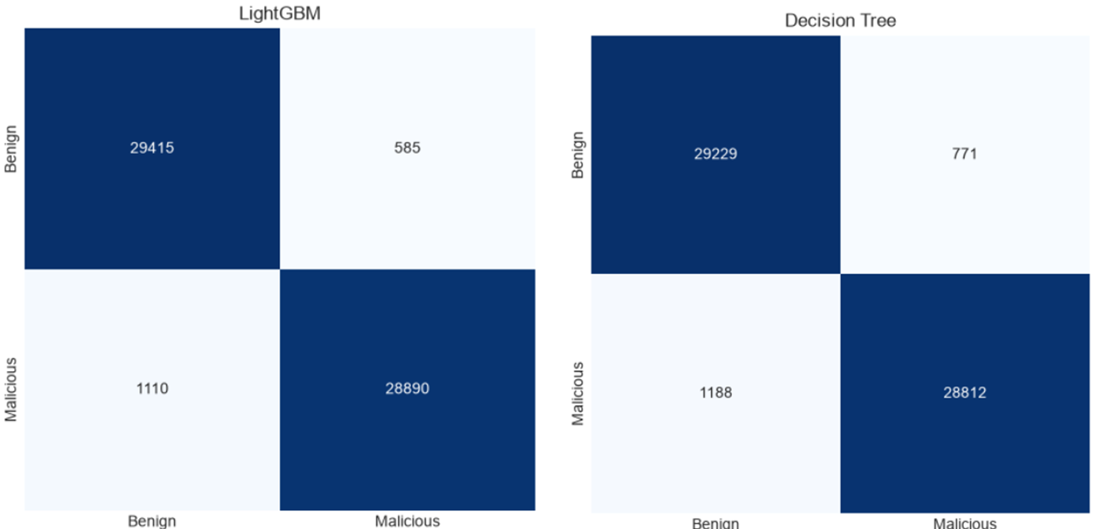
Fig. 3 Confusion matrices for LightGBM and DT

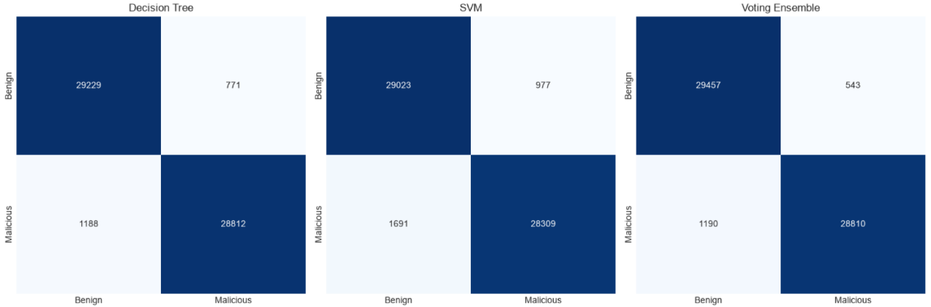
Fig. 4 Confusion matrices for SVM and VE

B. Model Result (ROC Curve)
The Receiver Operating Characteristic (ROC) curve was used to measure the classification ability of each model at different decision thresholds. The corresponding ROC-AUC value represents how well a model separates phishing QR codes from legitimate ones.

Fig. 5 ROC Curve Comparision
Among all evaluated models, XGBoost and LightGBM achieved the highest ROC-AUC score of 0.9960, indicating excellent discrimination between legitimate and phishing QR codes across different classification thresholds.

C. Comparative Analysis
Table II summarizes the overall performance of the six machine learning models using the selected evaluation metrics.
Table II Comparison of Model Performannce
Model | Acc. | Prec. | Recall | F1-Score | ROC-AUC
Random Forest | 0.9655 | 0.9820 | 0.9484 | 0.9649 | 0.9947
XGBoost | 0.9718 | 0.9801 | 0.9632 | 0.9716 | 0.9960
LightGBM | 0.9718 | 0.9802 | 0.9630 | 0.9715 | 0.9960
Decision Tree | 0.9674 | 0.9739 | 0.9604 | 0.9671 | 0.9852
SVM | 0.9555 | 0.9666 | 0.9436 | 0.9550 | 0.9864
Voting Ensemble | 0.9711 | 0.9815 | 0.9603 | 0.9708 | 0.9959

D. Model Result (Testing)
The trained model was further validated using two representative QR code samples from the test dataset to verify its real-world performance.
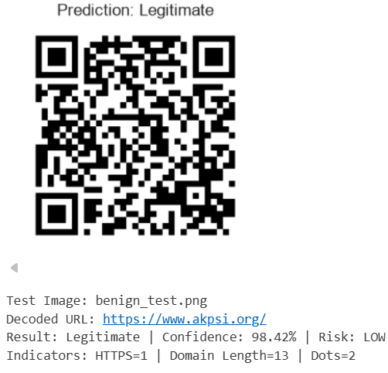
Fig. 6 Test Instance 1: Benign

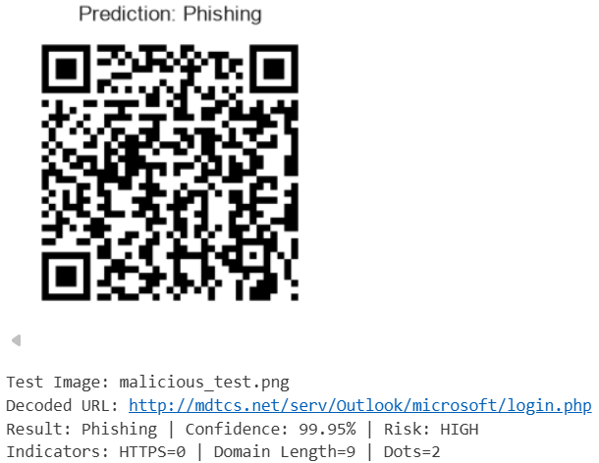
Fig. 7 Test Instance 2: Malicious

The testing results confirm that the proposed framework can successfully decode QR codes, extract both visual and URL-based features, and accurately classify them. The generated confidence score and risk level provide users with a clear indication of the security status of the scanned QR code before opening the associated link.

E. Discussion
The experimental results demonstrate that combining visual QR code features with lexical URL features improves phishing detection compared with approaches that rely on only one type of information. Visual features such as edge density, contour patterns, grayscale statistics, and image structure help identify changes or irregularities in QR codes, while URL-based features detect common phishing characteristics such as suspicious domains, insecure protocols, and unusual URL patterns. The combination of these complementary features contributes to more reliable classification.
Among the evaluated models, XGBoost and LightGBM achieved the highest classification accuracy of 97.18%. Both models showed excellent predictive performance, with XGBoost obtaining a slightly higher F1-Score (97.16%) due to its marginally better recall. These results demonstrate that gradient boosting techniques are highly effective for QR code phishing detection using the proposed hybrid feature set.
In addition, the use of parallel feature extraction and feature caching reduces preprocessing time, making the proposed framework practical for large datasets and real-time QR code phishing detection.

VI. Conclusion
This paper presented a hybrid machine learning framework for detecting QR code phishing (Quishing) attacks by combining visual information from QR code images with lexical features extracted from decoded URLs. The proposed approach uses a 21-dimensional feature vector consisting of 14 visual and 7 URL-based features, enabling the system to analyze both the structural characteristics of QR codes and the properties of the embedded links.
The framework was evaluated on a balanced dataset of 200,000 QR code images containing equal numbers of legitimate and phishing samples. Six machine learning classifiers were trained and compared to assess their effectiveness. Among them, XGBoost and LightGBM achieved the highest classification accuracy of 97.18%, with XGBoost recording the best F1-Score of 97.16%. The experimental results demonstrate that combining visual and lexical features provides better detection performance than methods that rely only on image analysis or URL analysis.
Overall, the proposed framework offers an accurate, scalable, and practical solution for real-time QR code phishing detection. The inclusion of a multi-level risk assessment mechanism further improves usability by providing clear security warnings before users access potentially malicious websites. These findings indicate that the proposed approach can effectively enhance QR code security in modern mobile and web environments.

VII. Future Work
Future research can focus on extending the proposed framework in several directions to improve its effectiveness and practical applicability. Lightweight deep learning models, such as MobileNetV4, can be explored to automatically learn visual features from QR code images while maintaining efficient performance on mobile devices. Incorporating webpage content analysis, domain reputation, and SSL certificate verification can further strengthen the detection of newly emerging phishing websites.
Another important direction is to improve the interpretability of the model by integrating Explainable AI (XAI) techniques such as SHAP or LIME, allowing users to better understand the factors that influence each prediction. In addition, the system will be evaluated against physically modified QR codes, including damaged, partially covered, or sticker-overlaid QR codes, to assess its robustness under real-world conditions.
The proposed framework can also be deployed as a mobile application or browser extension for real-time QR code scanning and risk assessment. Evaluating the system on larger and more diverse datasets collected from different environments will further improve its reliability and generalization for practical cybersecurity applications.

References
- R. Yalda, A. Khan, and N. Nepal, "B-PhishQR—A blockchain-based framework for secure QR code verification against phishing attacks," Telematics and Informatics Reports, vol. 21, p. 100289, 2026, doi: 10.1016/j.teler.2025.100289.
- A. S. Rafsanjani, N. B. Kamaruddin, H. M. Rusli, and M. Dabbagh, "QsecR: Secure QR code Scanner According to a Novel Malicious URL Detection Framework," IEEE Access, vol. 11, pp. 92523-92539, 2023, doi: 10.1109/ACCESS.2023.3291811.
- F. Nejati, M. Rabbani, M. Eskandarian, M. Mirani, G. Piya, I. Opushnyev, A. A. Ghorbani, and S. Dadkhah, "CIC-Trap4Phish: A Unified Multi-Format Dataset for Phishing and Quishing Attachment Detection," arXiv preprint arXiv:2602.09015, 2026.
- M. A. Ozuberk and I. Cinar, "Malicious QR Code Classification Using Machine Learning, Deep Learning, and Explainable AI," in 2026 5th International Informatics and Software Engineering Conference (IISEC), 2026, pp. 1-6, doi: 10.1109/IISEC69317.2026.11418433.
- F. Trad and A. Chehab, "Detecting Quishing Attacks with Machine Learning Techniques Through QR Code Analysis," arXiv preprint arXiv:2505.03451, 2026.
- M. W. Akram, K. Sood, M. U. Hassan, and D. Thiruvady, "ALFA: A Safe-by-Design Approach to Mitigate Quishing Attacks Launched via Fancy QR Codes," arXiv preprint arXiv:2601.06768, 2026.
- M. W. Akram, K. Sood, and M. U. Hassan, "QRïS: A Preemptive Novel Method for Quishing Detection Through Structural Features of QR," arXiv preprint arXiv:2510.17175, 2025.
- F. Ahmed, I. Fatima, M. U. Hassan, I. Rasheed, and U. Fayyaz, "Malicious QR Code Detection: A Comprehensive Review of Methods and Challenges," Spectrum of Engineering Sciences, vol. 3, no. 12, pp. 1462-1472, 2025, doi: 10.5281/zenodo.18196524.
- N. Nigam and R. Bhandari, "Performance Analysis of QR Phishing Detection Approaches," Journal of Information Systems Engineering and Management, vol. 10, no. 335, pp. 221-225, 2025.
- B. K. S., R. B. Bhuvaneshwari, P. S. Pavan, H. S. Varun, and J. G. C., "AI Based QR Code Fraud Detection System," International Journal of Innovative Research in Science, Engineering and Technology (IJIRSET), vol. 14, no. 12, pp. 22809-22815, 2025, doi: 10.15680/IJIRSET.2025.1412039.
- R. Osari, K. K. Baraskar, G. Silakari, P. Jain, P. Jain, and P. Verma, "Design and Analysis of Machine learning based QR Phishing Detection System," International Journal of Advanced Research in Science, Communication and Technology (IJARSCT), vol. 5, no. 12, pp. 67-76, 2025, doi: 10.48175/IJARSCT-25909.
- M. Sarkhi and S. Mishra, "Detection of QR Code-based Cyberattacks using a Lightweight Deep Learning Model," Engineering, Technology & Applied Science Research, vol. 14, pp. 15209–15216, 2024.
- S. Vaithilingam and S. A. M. Shankar, "Enhancing Security in QR Code Technology Using AI: Exploration and Mitigation Strategies," International Journal of Intelligence Science, vol. 14, no. 2, pp. 49–57, 2024.
- F. Sharevski, M. Mossano, M. F. Veit, G. Schiefer, and M. Volkamer, "Exploring Phishing Threats through QR Codes in Naturalistic Settings," in Proceedings 2024 Symposium on Usable Security, 2024.
- J. Ford and H. S. Berry, "Feasibility of Machine Learning-Enhanced Detection for QR Code Images in Email-based Threats," 2024 Cyber Awareness and Research Symposium (CARS), Grand Forks, ND, USA, 2024, pp. 1-9, doi: 10.1109/CARS61786.2024.10778732
- M. K. Bhagwani, A. Gangwar, K. Vishwakarma, A. Khare, V. K. Tiwari, and A. Dubey, "Preventing Malware Spread through QR Codes: A Detection and Analysis Approach," J. Eng. Technol. Manage., vol. 73, pp. 1260-1268, Sep. 2024.
- S. A. Galadima, M. Shrivastava, and G. Sonowal, "QR Code Phishing: A Review of the Current Attacks and Countermeasures," JuniKhyat, vol. 14, no. 9, no. 3, pp. 1-6, Sep. 2024.
- K. A. Khalique, "Detecting Phishing URLs in QR codes using Heuristic Techniques," M.S. thesis, School of Computing, National College of Ireland, Dublin, Ireland, Sep. 2023.
- S. Dhanraj, N. B. B. K, N. A. Jain, M. Manisha, and M. Keerthana, "Malicious URL Detection Using Machine Learning and Deep Learning," Int. J. Adv. Res. Comput. Commun. Eng., vol. 12, no. 2, pp. 109-113, Feb. 2023, doi: 10.17148/IJARCCE.2023.12223.
- B. Herlina and H. Soeparno, "Machine Learning Model to Improve Classification Performance in the Process of Detecting Phishing URLs in QR Codes," J. Theor. Appl. Inf. Technol., vol. 101, no. 18, pp. 5755-5765, Sep. 2023.

Proof of Submission:-




